
April 2018
This publication was produced at the request of the SWFF Technical Assistance Facility. It was prepared independently by Ipsos under the guidance of Securing Water for Food.

SECURING WATER FOR FOOD
EVALUATION

Project Title: Evaluation of Reel Gardening
SWFF Innovator: Reel Gardening
Support Provider: Ipsos

Evaluation of Reel Gardening

a VALIDATION OF IMPACT DATA FROM REEL GARDENING

May 29, 2018

USAID Contract AID-OAA-C-15-00011

DISCLAIMER
The author’s views expressed in this publication do not necessarily reflect the views of governments, of Sweden, the Netherlands, South Africa, nor the United States Government.

Contents

Acronyms 1
Executive Summary 2
Evaluation Purpose & Evaluation Questions 4
Project Background 5
Evaluation Methods & Limitations 7
Findings 11
Conclusions and Recommendations 30
Annex 1: Statement of Work 32
Annex II: Evaluation Design 36
Annex III: Data Collection Instruments 44
Annex IV: Sources of Information 60
Annex V: Adjustments to Submitted Data………………………………………..62
Annex VI: Disclosure of Conflicts of Interest 63

Acronyms

AWP ACCELERATION WORK PLAN
BOGO BUY-ONE, GIVE-ONE
BOP BASE OF PYRAMID
CSI CORPORATE SOCIAL INVESTMENT
HA HECTARES
IDI IN-DEPTH INTERVIEW
KG KILOGRAM
M² SQUARE METERS
RFP REQUEST FOR PROPOSAL
RG REEL GARDENING
SOW STATEMENT OF WORK
USAID U.S. AGENCY FOR INTERNATIONAL DEVELOPMENT

Executive Summary

INTRODUCTION
This report contains the findings of an evaluation of the impact data submitted by Reel Gardening, a SWFF innovation. The purpose of the evaluation was to validate these data and to draw conclusions on whether Reel Gardening was able to achieve its intended outcomes of growing more food with less water, and to judge whether these effects are in line with SWFF goals. SWFF will use the results of this evaluation to make a final determination on Reel Gardening’s success during the time of its participation in SWFF programming. This will also inform Reel Gardening’s methods for meeting milestones and can serve as guidance for future SWFF activities.

Project Background
Reel Gardening is a SWFF Round 1 innovation based in South Africa that developed a unique seed system that can be grown into a vegetable or herb garden through pre-packaged paper strip with seeds and fertilizers, allowing for easier planting and maintenance, and reduced water use as compared to traditional methods.

The Reel Gardening model claims to have a profound and combined impact in the fields of nutrition, education, income, water conservation and entrepreneurship for low-resourced communities. They have done this most directly by working with schools across South Africa to implement school gardens and guiding them in the ongoing management of the gardens. Reel Gardening pivoted their business model in the last year of their program cycle, shifting towards a strategy that emphasizes the commercial sales of products in order to subsidize its work with schools and other beneficiaries.

evaluation METHODOLOGY
Ipsos, an independent research company specializing in impact evaluation, conducted this evaluation between January and April 2018. This evaluation centered around specific pre-determined key indicators for which Reel Gardening submitted impact data over the three years of their SWFF program cycle. These indicators were aligned with SWFF’s evaluation questions, which sought to determine the magnitude of the effect that Reel Gardening had on its intended outcomes and results. The evaluation questions and indicators are outlined in detail the Evaluation Methods section below.

Data sources for these evaluation questions consisted of:
- A comprehensive review of program data submitted to SWFF
- Primary data collection via quantitative surveys and qualitative in-depth interviews with customers and in Reel Gardening schools which yielded new insights that helped validate Reel Gardening data.

The purpose of the desk review was twofold: first, to better understand the history and operations of Reel Gardening throughout its years of SWFF funding and secondly, to allow for in-depth analysis of the data submitted by Reel Gardening for each indicator. This was done through examination of sales records, reports, and other documents provided by both SWFF and Reel Gardening.

Quantitative surveys were administered to 12 Garden Champions (Y1/Y2 schools), 4 teachers (Y3 schools) a and 16 Kitchen Worker (both Y1/Y2 and Y3. The purpose of these surveys was to quantify student participation, produce grown, and nutrition benefits realized from the garden. Participants were selected based on school location and history of interaction with Reel Gardening garden or produce.

Qualitative interviews were conducted with eight corporate and individual customers. The purpose of these interviews was to elicit information specific to each stakeholder’s knowledge base and experience with Reel Gardening, as it related to each evaluation question. These interviews provided detailed insight on Reel Gardening’s products, customer base, business relationships, potential sustainability, and evolution.

While every effort to mitigate shortcomings was taken during the evaluation process, a number of limitations must be considered. Key limitations included the restricted budget resulting in small, non-representative samples, and the retrospective design, leading to recall issues among quantitative and qualitative interviewees.

Findings And conclusions
Data submitted by Reel Gardening to SWFF across a number of pre-determined indicators was concluded to be, on the whole, a valid representation of the degree of impact that Reel Gardening had on its intended outcomes during its time under SWFF programming. Some revisions to Reel Gardening data were needed because of issues with consistent measurement across program years, as well as adjustments recommended by Ipsos based on evaluation findings. Ipsos made these revisions as necessary, and the figures throughout this report represent adjusted data. Explanations of revisions can be found in Annex V.

Given the scope of the evaluation questions above and the findings on each aligned indicator, it can be concluded that while the data submitted by Reel Gardening may need some revisions, based on available evidence they have achieved their stated impact on the SWFF goals of producing more food using less water.

Evaluation Purpose & Evaluation QuestionS

EVALUATION PURPOSE
Reel Gardening, a Securing Water for Food (SWFF) Round 1 innovation, is nearing the end of its program life cycle. This evaluation served to validate the impact data that Reel Gardening submitted to SWFF, and add new insights regarding Reel Gardening’s impact. The goal of this evaluation was to examine whether the Reel Gardening business model and products aligned with stated SWFF goals to increase both food production and water efficiency in an agricultural innovation.

Results of this evaluation will be used to make a final determination on Reel Gardening’s success over the time of its participation in SWFF programming. Further, this evaluation will contribute to an ongoing three-year SWFF program performance evaluation of all Round 1 and Round 3 awards, and will add to the US Global Development LAB’s portfolio of innovation. Lessons learned from this process will contribute to improving Reel Gardening’s methods for meeting its goals, and can serve as guidance for future evaluation activities undertaken by SWFF.

EVALUATION QUESTIONS
This evaluation sought to examine the evidence provided by Reel Gardening towards its intended outcomes and SWFF goals. SWFF developed six evaluation questions to determine the magnitude of the effect that Reel Gardening had on its intended outcomes:
- Evaluation Question 1: Did Reel Gardening meet their agricultural productivity targets based on evidence from this evaluation?
- Evaluation Question 2: To what degree did Reel Gardening increase water efficiency through the seed tape as compared to traditional South African gardening practices?
- Evaluation Question 3: To what degree did Reel Gardening have the demonstrated impact of growing more food using less water for the target groups as noted in its milestones and the evidence provided to SWFF?
- Evaluation Question 4: To what degree is there demand for and local ownership of Reel Gardening seed tape?
- Evaluation Question 5: To what degree do vulnerable groups (the poor, women, ethnic minorities) in societies benefit (income, employment, water) from the Reel Gardening seed tape versus other available alternatives?
- Evaluation Question 6: To what degree is the seed tape likely to be sustainable under the Reel Gardening organization?

Data that Reel Gardening submitted to SWFF was organized around these overarching questions in the form of specific indicators developed by SWFF. Further details can be found in the Evaluation Methodology section below.

Project Background

PROGRAM OVERVIEW
Reel Gardening is a South Africa-based organization that developed an innovative seed system they claim can be grown into a vegetable or herb garden in nearly any climate. The innovator pre-packages a paper strip with seeds and fertilizers so it can be easily planted at the correct depth, and requires minimal maintenance to thrive.

The Reel Gardening model claims to have a profound and combined impact in the fields of nutrition, education, income, water conservation and entrepreneurship for low-resourced communities. From the beginning, Reel Gardening has been a company dedicated to serving the poor by providing them the means to produce healthy produce at low cost. They have done this most directly by working with schools across South Africa to implement school gardens and guiding them in the ongoing management of the gardens. The funding for these school gardens has come largely through a partnership with Unilever and other South African corporations utilizing Corporate Social Investment (CSI) money.

PROGRAM evolution
During Y1 of their SWFF award, Reel Gardening hypothesized that supporting schools in creating Reel Gardening gardens, could:
a) Impact the quality of food that was supplied to learners through the school feeding scheme.
b) Catalyze sales of Reel Gardening to the community involved with and surrounding targeted schools.
To this end, Reel Gardening donated 400m² Gardens in a Box to schools around South Africa, hoping to help supply nutritious meals to children in low-income or “bottom of the pyramid” (BOP) households. With enough planting material to supply a 400m² garden in each school, the average amount of land available for planting at schools, these gardens were not intended to feed an entire school sustainably, but instead to augment the school’s food supply. School gardens were used as an outdoor classroom to teach the whole school how to grow food. Reel Gardening trained agent/trainers to conduct all the necessary training at schools to equip “garden champions” at each school to care for their new garden effectively and to guide them through their first growing cycle. This model met with significant challenges resulting in varied success across schools. The primary reasons for included the lack of investment and support from key leaders such as school principals, as well as challenges in finding reliable trainers.
A second aspect of the Y1 model was focused around creating entrepreneurship activities. Each agent/trainer was stocked with a micro-consignment of Reel Gardening seed tape with the intention that they could sell the products to the local community and establish their own micro-business. However, by the end of Year 1, it became clear that there was little demand in the community to buy these products and sales were not materializing. Based on feedback from schools and trainers, the primary reason for this was that low-income schools were deliberately targeted, many potential buyers were not willing or able to buy the seed tape (which is more expensive than the seeds alone), and were accustomed to receiving agricultural supplies for free through aid programs.
Securing Water for Food saw that Reel Gardening’s initial model need to be revised and from the end of Year 2 of the project onwards, Reel Gardening pivoted to a strategy that emphasizes commercial, profitable sale of its products so that they could use a portion of profits to subsidize the work with schools and communities. This served the dual purpose of continuing to aid the intended beneficiaries, while reducing Reel Gardening’s dependence on corporate partnerships for funding and revenue. As part of this shift, Reel Gardening, with support from the SWFF TA Facility, developed a Buy One Give One (BOGO) component for its business model, making strong progress towards a dual social enterprise model in which the profit-making entity funnels profits to support the local communities that cannot afford the seed tape. Reel Gardening started rolling out this Buy One Give One scheme in May 2017, with the first retail partnership commencing in the United States through Girl Scouts of America. Moving forward, for all Reel Gardening product sold in a middle- or high-income retail environment, seed tape is donated to schools and communities within South Africa to further Reel Gardening’s positive social impact at the BOP level in a sustainably-funded manner.
Understanding Reel Gardening’s program logic through a Hypothesis of Change is helpful in thinking through the evolution of the program. Moreover, a Hypothesis of Change is instrumental in developing an evaluation approach and aligning evaluation objectives with overall program goals.

Figure1 illustrates the evolution of Reel Gardening’s model through a simplified Hypothesis of Change.

Figure 1: Reel Gardening Hypothesis of Change
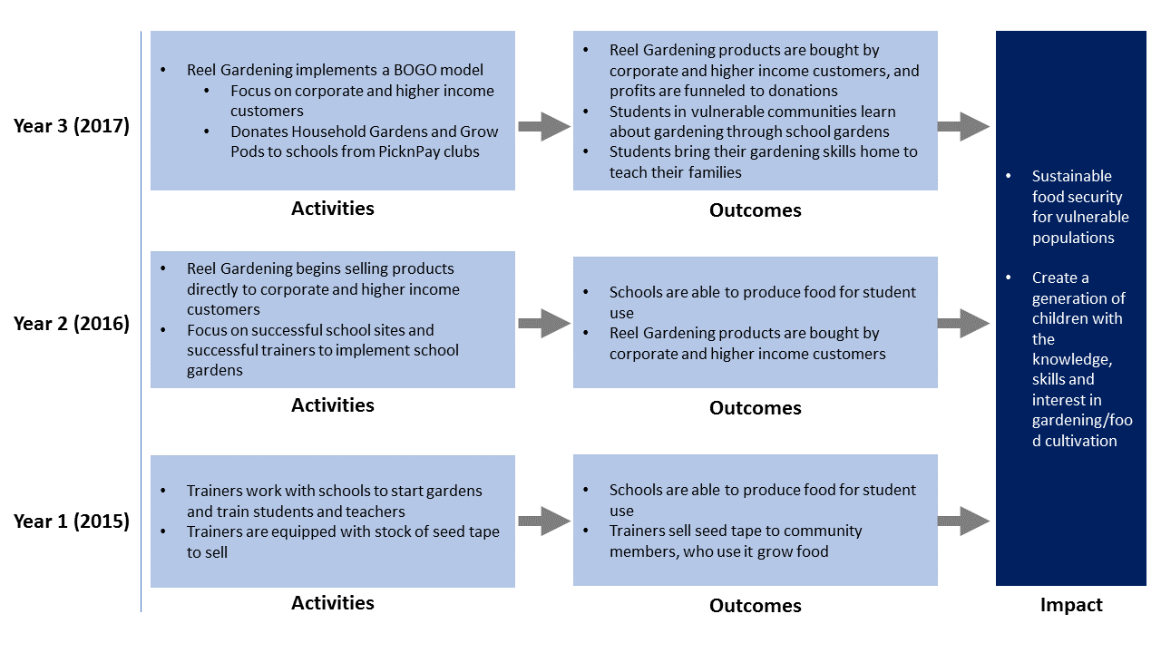

The evolution of the Reel Gardening program, as illustrated above, was considered during the evaluation design. In addition, the consequences of the shift in focus are discussed in the findings, as the pre-determined indicators were initially developed for the original Y1 model. Therefore, as SWFF changed their approach in Y3, the data submitted for that year must be considered in light of the new approach.
EVALUATION METHODS & LIMITATIONS

SWFF engaged Ipsos, an independent research company specializing in impact evaluation, to conduct this validation study.

With the aim of validating Reel Gardening data and further exploring Reel Gardening’s impact towards SWFF goals, the approach to this evaluation was focused around a series of pre-determined indicators for which Reel Gardening had previously submitted data. The matrix in Table 1 below links each evaluation question to the indicators that support it and the data source used to validate it. A description of each data source can be found below.

Table 1: Evaluation Questions and Associated Indicators, Data Sources, and Considerations
Evaluation Questions | Indicator(s)  (Data submitted by Reel Gardening) | Validation Data Source(s)
Evaluation Question 1: Did Reel Gardening meet their agricultural productivity targets based on evidence from this evaluation? | - Area of land in production  - Volume of produce grown | - Desk Review  - Quantitative Data Collection from RG schools
Evaluation Question 2: To what degree did Reel Gardening increase water efficiency through the seed tape as compared to traditional South African gardening practices? | - Agricultural water consumption reduction | - Desk Review  - Quantitative Data Collection from RG schools
Evaluation Question 3: To what degree did Reel Gardening have the demonstrated impact of growing more food using less water for the target groups as noted in its milestones and the evidence provided to SWFF? | Given the scope of this evaluation/validation exercise, Evaluation Questions 1 and 2 are considered sufficient to cover this evaluation question.
Evaluation Question 4: To what degree is there demand for and local ownership of Reel Gardening seed tape? | Considered under Evaluation Question 6 | - Desk Review  - Quantitative Data Collection from RG schools
Evaluation Question 5: To what degree do vulnerable groups (the poor, women, ethnic minorities) in societies benefit (income, employment, water) from the Reel Gardening seed tape versus other available alternatives? | - Total number of beneficiaries/end users | - Desk Review  - Quantitative Data Collection from RG schools  - Qualitative Data Collection with customers
Evaluation Question 6: To what degree is the seed tape likely to be sustainable under the Reel Gardening organization? | - Total product sales  - Profit margin  - Matching funds  - Percentage of products re-purchased | - Desk Review  - Qualitative Data Collection with customers

Desk review
The purpose of the desk review was twofold: first, to better understand the history and operations of Reel Gardening throughout the time of its program relationship with SWFF, and secondly, to allow for in-depth analysis of the data that Reel Gardening submitted to SWFF for each indicator. The desk review included a number of documents provided by SWFF and Reel Gardening collected over the three-year duration of the program, including: sales records, semi-annual and annual reports, SWFF milestone tracking records, and trainer reports.

Review of these documents was important in facilitating conclusions about the evolution of the Reel Gardening program and design. They also served to inform the overall evaluation methodology and the design of quantitative and qualitative instruments for independent data collection.

In terms of the second objective, the desk review provided the foundation analysis on how each data point submitted by Reel Gardening was calculated. In particular, the SWFF milestone tracking records, referred to herein as the “Milestones Spreadsheets” was instrumental in detailing and tracking the final production of data submitted.

Quantitative data collection
Quantitative data collection was an important element of verifying information assessed in the desk review and addressing the evaluation questions. Participants in Reel Gardening’s school programming were selected for participation in quantitative data collection based on location as well as by role related to garden involvement.

For Y1 and Y2 schools, interviews included:
- Garden Champions, who were responsible for maintaining school gardens. These are typically community members or school maintenance staff.
- Kitchen Workers, who were able to speak to the school feeding programs and have direct experience in using the vegetables from the Reel Gardening gardens for student meals

While the focus of fieldwork was on validating data from Y1 and Y2, a small sample of schools under the Y3 model were included to gain insight into the impact that the new model is having on schools. Interviews at Y3 schools included:
- Teachers who were able to speak to the Y3 program focus on learning
- Kitchen Workers, who were able to speak to the school feeding programs and have direct experience in using the vegetables from the Reel Gardening gardens for student meals

Tables 2 and 3 below illustrate the breakdown of sampling for schools. Detailed sampling strategies for each data source can be found in Annex II: Evaluation Methods and Limitations.

Table 2: Quantitative Fieldwork Sample (Year 1 and Year 2 Schools)
Province | # of Y1/Y2 School Sites | # of Garden Champion interviews per school site | # Kitchen Worker interviews per school site | Total number of interviews per province for Y1/Y2
Gauteng | 3 | 1 | 1 | 6
KwaZulu Natal | 3 | 1 | 1 | 6
Mpumalanga | 3 | 1 | 1 | 6
North West | 3 | 1 | 1 | 6

Table 3: Quantitative Fieldwork Sample (Year 3 Schools)
Province | # of Y3 School Sites | # of Teacher interviews per school site | # Kitchen Worker interviews per school site | Total number of interviews per province Y3
Gauteng | 1 | 1 | 1 | 2
KwaZulu Natal | 1 | 1 | 1 | 2
Mpumalanga | 1 | 1 | 1 | 2
North West | 1 | 1 | 1 | 2

Questionnaires were designed to address the indicators associated with the total number of beneficiaries, area of land in production, volume of produce grown and agricultural water consumption reduction, as well as perceived effectiveness of RG products and programming. Questionnaires can be found below in Annex III. The survey was administered face-to-face via computer-assisted interviewing (CAPI) by the Ipsos South Africa team.

QUALITATIVE DATA COLLECTION
To supplement and inform desk research and to validate findings, qualitative interviews were also conducted. Table 4 below illustrates the customer types for which interviews were completed.

Table 4: Qualitative Fieldwork Sample (Year 3 Schools)
Customer Type | # of completed interviews
Corporate Customer | 4
Individual Customer | 2

Qualitative instruments, in the form of discussion guides were designed to elicit information specific to each customer’s knowledge base and experience with RG, pursuant to their relationship and relevance to each evaluation question. Discussion guides can be found below in Annex III. Analysis was conducted through team debrief and annotated documentation of conversations.

These interviews provided insight into RG’s operations and activities, as well as indicators relating to SWFF targets, particularly in terms of customer behaviors and perceptions and areas for improvement. When possible, documentation was obtained from participants to supplement and verify points of discussion.

Further details on the study methodology can be found in Annex II.

Limitations of the Evaluation Approach
While the main strength of this evaluation was the independent primary data collection with Reel Gardening beneficiaries, which yielded new insights into Reel Gardening performance, there are several limitations:

- The quantitative survey was based on a small, non-random sample. While the sample was designed to be broadly representative, statistically significant conclusions cannot be drawn from findings. Additionally, findings are reported in raw numbers rather than percentages because of the small sample size.
- Sample selection for the quantitative survey was determined by factors including: reliability of data in past reports, location of and ease of access to schools, and ability to contact the Garden Champion. These factors may have biased the sample towards schools that were more successful, as Garden Champions remained in place, and that had high performing trainers. Consequently, there were no qualitative interviews conducted at school gardens that Reel Gardening had considered to have “failed”.
- Due to the pre-determined validation goal of this study, the focus was on Y1/Y2 schools, and therefore the findings are concentrated on these years. The study did include a limited (n=4) selection of Y3 schools, but it is difficult to be conclusive about the findings for this group.
- Garden Champion recall was challenged by two factors. First, this was a retrospective study with Y1/Y2 schools, which ended their engagement with Reel Gardening in 2016 or earlier. Second, in many of the schools, gardens had existed before Reel Gardening rolled out their program, or a garden continued after the program using traditional gardening methods. Garden Champions may not have been able to remember details about the garden from two years ago, or they may have confused their current or past garden with the Reel Gardening program. Wherever possible, mitigation strategies were put in place to anticipate these issues. For example, interviewers brought examples of seed tape and trainer uniforms to remind them, and the questionnaires were structured in a way as to ensure that they were referring to a Reel Gardening garden and not another school garden.
- Garden Champions and Kitchen Workers had difficulty answering questions that required detailed numeric answers, such as measuring the amount of produce harvested or the amount of water used. This may be because of low levels of literacy and numeracy.
- Garden Champions, Teachers and Kitchen Workers had not previously collected data on the metrics of interest in this evaluation in the questionnaire, such as amount of produce harvested or amount of water used. Thus, their responses to these questions can only represent best estimates.
- The selection of customers, both individual and corporate, was dependent on their willingness to engage in an interview. While representatives of corporate customers were happy to engage, it was difficult to recruit individual customers. This is partly due to privacy laws in South Africa, which dictate that customers have to opt in to have their contact information shared.

Findings

ORGANIZATION OF FINDINGS
Evaluation findings are organized by key program indicator, which are aligned with the evaluation questions, and were pre-determined by SWFF and Reel Gardening in accordance with SWFF M&E policies. These indicators include the following:

Technical Indicators:
- Total number of beneficiaries/end users
- Hectares (ha) of delta, estuarine, or agricultural land (fields, rangeland, agro forests) in production as a result of SWFF innovation
- Volume of produce grown (in kilograms)
- Agricultural water consumption reductions (by volume in liters) as a result of SWFF innovation

Financial Indicators
- Percentage of gardens re-purchased/re-planted
- Value of sales (collected at farm-level) attributed to SWFF innovation
- Profit margin by product

For each indicator, a summary table is presented which includes:

(1) The Reel Gardening data submitted for each year of SWFF funding in Column A, which was determined by examining the following documents submitted by Reel Gardening to SWFF: Annual Reports, Milestone Spreadsheets, RG Year 1 and Year 1 Reports, and Overall Indicator Achievement Spreadsheet. Ipsos performed auditing tasks to uncover how each indicator was calculated by Reel Gardening and clarify the assumptions involved in the calculations.

(2) A high-level summary of findings on that data in Column B, which is based on learnings from the auditing of the documents above, as well both quantitative and qualitative fieldwork performed by Ipsos. Findings are informed by the analysis of data from Garden Champion and Kitchen Worker surveys, as well as qualitative interviews with stakeholders. All charts displayed below are based on surveys, which can be found in Annex III.

SWFF Funding Years
Analysis is also organized into SWFF funding years, which was scheduled as follows:

YEAR 1: October 1 2014 – September 31 2015
YEAR 2: October 1 2015 – September 31 2016
YEAR 3: October 1 2016 – March 31 2018

Because of the shift in business model, Year 1 and Year 2 schools (Y1/Y2 schools) will grouped together in analysis, as the same programmatic approach was applied in both years. Year 3 schools (Y3 schools) are treated separately, as Reel Gardening fully shifted their approach in this year.

Distribution Categories of Product Sales
The foundation for all of the indicators below is the spreadsheets of product sales listed in the first tab of the Milestones spreadsheet for each year. Product sales account for each and every unit of Reel Gardening product that was shipped out, whether purchased or donated. Each sale is also attributed to a customer and these customers are grouped two different distribution categories: school gardens and household gardens. Details for each category can be found in Table 3 below.

These distribution categories represent the two primary methods in which Reel Gardening products were delivered and used and each has specific Reel Gardening products associated with it. Distinguishing between these categories is important because some indicators use different calculation approaches and assumptions for the two different distribution categories.

Table 5. Reel Gardening products related to distribution categories
Distribution Category | Description | Product
School garden | These refer to Garden in a Box products that went to school or community sites where Reel Gardening rolled out the trainer/Garden Champion model in Year 1 or Year 2 or the teacher and curriculum model in Year 3. The majority (89% in Year 1 and 74% in Year 2) of these product sales went to schools funded by SWFF or Unilever, or to an implementing partners such as Space and are considered to be school garden sites. The other sites are part of matching fund partners such as Nampak, Curo, Sanlam, AKTV. There are a small percentage (1% in Year 1 and 5% in Year 2) of product sales that went to a variety of other customers. | 200m² Garden in a Box (Y1/Y2 schools)  (2 200 m² Gardens in a Box were given to each school for a total of a 400m² garden)
School garden |  | Grow Pods (Y3 schools)
Household garden | These refer to products intended for household use. Customers of household gardens include: corporate bulk purchases, retail reseller bulk purchases and individual direct customers. | 100m² Garden in a Box
Household garden |  | 50m² Garden in a Box
Household garden |  | Sachets
Household garden |  | Seed Tape units
Household garden |  | Large Household Boxes
Household garden |  | Small Windowsill Gardens
Household garden |  | Kids Get Growing Gardens
Household garden |  | Custom Branded Seed Tape

FINDINGS: TECHNICAL INDICATORS

- TOTAL NUMBER OF CUSTOMERS/END-USERS
This indicator provides evidence on Evaluation Question 5: To what degree do vulnerable groups (the poor, women, ethnic minorities) in societies benefit (income, employment, water) from the Reel Gardening seed tape versus other available alternatives? With SWFF’s pro-poor focus, the beneficiary focus for Reel Gardening is on vulnerable populations, specifically Base of the Pyramid (BOP) end-users. Through an understanding of the number of total end-users, who the end-users are and how they benefit, we can better assess the degree to which vulnerable groups are impacted by this innovation.

Table 6. Summary of total amount of low income vs. total end-users
 | - Reel Gardening Data | - Summary of Findings
Year 1 | 38,557 low-income end-users  (356,453 total end users) | - There is evidence that the number of beneficiaries per school for Y1/Y2 schools was higher than assumed.  - There are additional means through which students benefit from gardens. If the definition of beneficiary is widened, then the total number of beneficiaries could increase.  - School gardens are known to have not all been maintained consistently. Therefore, beneficiaries may not have received benefits for the full year.  - Y1 and Y2 counted all household garden beneficiaries, despite economic status. If only BOP beneficiaries are to be counted, then the total number of beneficiaries for Y1 and Y2 will decrease substantially.
Year 2 | 42,611 low-income end-users  (135,092 total end users)
Year 3 | 61,896 low-income end-users  (311,802 total end users)
% Female | 50% school gardens, 51% household gardens | There is evidence to suggest that girls and women use and benefit from the Reel Gardening products more, so female end-users are likely higher than 50%.

TOTAL NUMBER OF END USERS VS TOTAL NUMBER OF LOW-INCOME END-USERS
Reel Gardening data includes figures for both the total number of end users as well as total number of low-income end-users. For the purposes of SWFF reporting, we assume that “end users” refers to all customers who used a Reel Gardening product of any kind, regardless of income level. End users includes all paying customers, as well as all students. Low-income end-users refers to, those in the low or low-middle income classes, referred here as “Bottom of the Pyramid” or BOP.

For this indicator, SWFF accepted Reel Gardening data for number of low-income end-users and total number of end users. Indicators that follow are based on the total number of end users.

The calculations for both low-income end-users and total end users are tied to product sales, as the nature of the product and project format make direct counting too difficult to realistically accomplish. Because of this, calculations of low-income end-users were derived from an analysis of product sales and the number of low-income end-users associated with each product.
Because different calculation methods and assumptions were applied to school garden product sales and household garden product sales, the findings below are organized according to these categories. It should be noted that all school garden users are considered to be low-income end-users, as the demographic makeup of the schools in the Reel Gardening program include entirely BOP populations. Household garden users include some BOP low-income end-users. These have been counted only where Reel Gardening could verify the income class of the end user and confirm that they are BOP.

When comparing the total number of low-income end-users from Y1 to Y3, we see an increase overall. This can be attributed to the fact that, in shifting their model from Y1 to Y3, Reel Gardening significantly expanded the number of schools they worked with, from 200 in Y1 to over 2,000 in Y3. Though the overall number of low-income end-users per school is lower in the Y3 model, the increase in number of schools still allowed the number of low-income end-usersto grow. In addition, the BOGO model of Y3 allowed Reel Gardening to donate a larger number of seed tape products, which also increased their total number of low-income end-users. More details are included in the sections below.

While total number of low-income end-users increased form Y1 to Y3, the total number of end users appears to decrease from Y1 to Y3. This is misleading, however, as 86% of total end users in Y1 are a result of custom branded seed tape purchases from Unilever, another Reel Gardening supporter. These Unilever purchases were not continued in Y2 or Y3, leading to a decrease in number of total end users. When total number of end users is examined without Unilever support in Y1, we see an increase of 83% of end users from Y1 to Y2 and an increase of 506% from Y1 to Y3. More details are included in the financial section below.

TOTAL NUMBER OF LOW-INCOME END-USERS AT SCHOOL GARDENS
Low-income end-users in school gardens were considered to be students, as the end users who benefitted by consuming vegetables from school gardens. The demographic makeup of the schools involved in Reel Gardening programming allow us to assume that school low-income end-users are classified as BOP.

However, when examining the reported numbers and composition of school low-income end-users, in addition to analyzing results from interviews with Garden Champions, Kitchen Workers and Teachers, Ipsos data suggest that the Reel Gardening data for school garden low-income end-users should be revisited and possibly revised in three ways:

- Assumption of number of low-income end-users per school
Because of the limited scale of Reel Gardening resources, monitoring systems were not able to track the number of students who benefitted at each school in a time and cost-efficient manner. Thus, to calculate the number of school garden low-income end-users, standardized assumptions were implemented about the number of students who benefit per school. These assumptions were multiplied by the number of schools in the program (in Y1 and Y2) and the number of Grow Pods given to schools (Y3). Table 7 below illustrates each assumption and how total number of school garden low-income end-users was determined by Reel Gardening.

Table 7. School beneficiary assumptions
Program Year | Number of Schools | Number of low-income end-users  Assumed | TOTAL NUMBER OF SCHOOL END-USERS
Y1 schools (400m² gardens) | 200 | 150 students per school | 30,000
Y2 schools (400m² gardens) | 186.5 | 150 students per school | 27,975
Y3 schools (Grow Pods and Learn and Grow Kits | 6,696 Grow Pods  (3 Grow Pods per school = 2,232 schools  1524 Learn and Grow Kits | 2 students per Grow Pod  (3 Grow Pods per school = 6 students per school)  4 students per Learn and Grow Kit = 6,069 additional student end-users | 19,488

Year 1 and Year 2 Schools
When Reel Gardening first conceived of the school garden programs, they envisioned that students would eat produce grown from the school gardens and this model was applied to schools in Y1 and Y2. As noted above, monitoring systems did not accurately and consistently count the number of students who ate vegetables from school gardens. However, Reel Gardening used consultations with trainers to estimate an average of 150 students per school that benefitted in the 200 program schools in Y1 and 233 schools in Y2. An analysis of school size of Y1/Y2 schools (based on Y1 School List provided by Reel Gardening) reveals that 150 students represents an average of 19% of students at the average size school.

Fieldwork at Y1/Y2 schools revealed that students did benefit by eating produce grown. Every Garden Champion respondent in this study noted that vegetables from the Reel Gardening garden went to students in the form of meals or vegetables to take home. Kitchen Workers, who are more aware of the eating habits and food distribution at schools, echoed this, verifying the responses from Garden Champions.

When asked about the total percentage of students at their school who had eaten vegetables from the Reel Gardening garden, Kitchen Workers responded with a range from 30% to 100%, as illustrated below in Figure 2, which stands in contrast to the 19% estimated by Reel Gardening.

Figure 2. What percentage of students in this school do you think ate vegetables from the Reel Gardening garden?
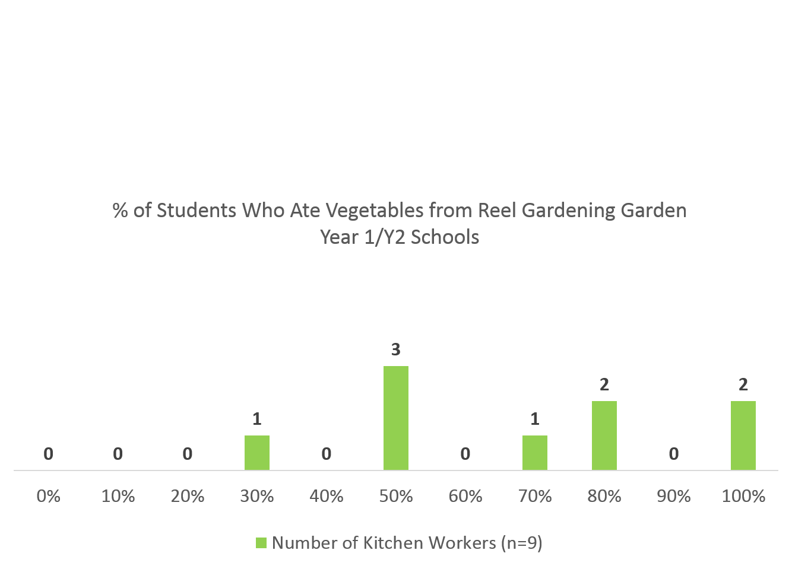

In addition, when asked about the frequency that they used vegetables from the Reel Gardening garden in meals cooked for students, Kitchen Workers reported a variety of times per week, shown below in Figure 3. Kitchen Workers cooked with vegetables at least once a week and some used them every day. This indicates further evidence of providing student meals, at least when gardens were being maintained.

Figure 3. How often did you typically use the vegetables from the Reel Gardening garden in meals you cooked for students?
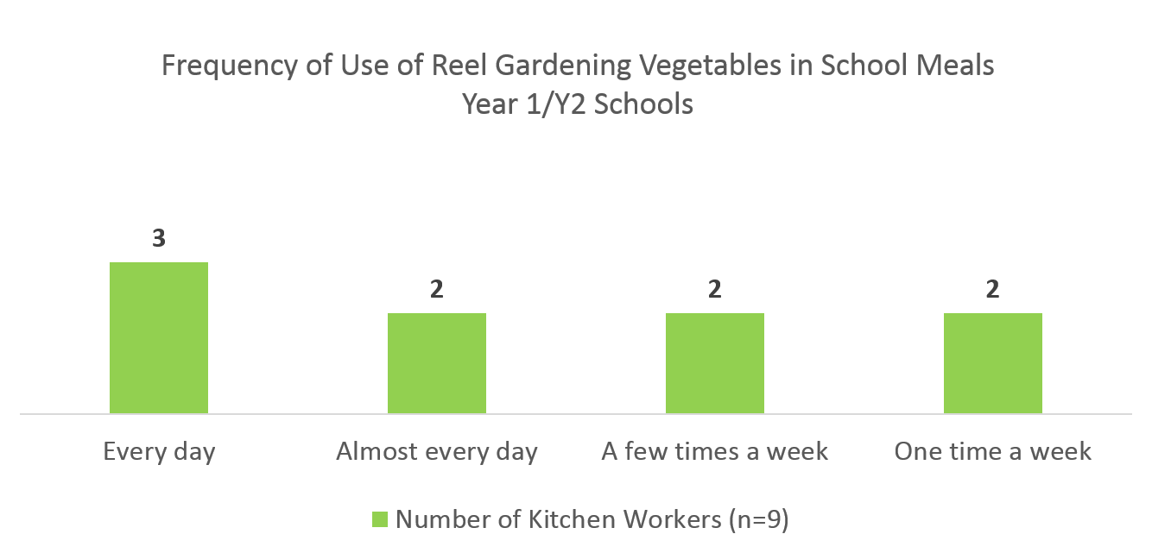
There is evidence to suggest that the percentage of end-users per school in Y1 and Y2 was higher than assumed by Reel Gardening and the number of those benefiting from school gardens should be increased.

However, this suggested increase should be tempered by the fact that there is further evidence, discussed in later sections to suggest that productivity differed across schools, and some gardens fell into disuse over time. Thus, these two trends likely cancel each other, and the estimations for number of students per school are reasonable.
Year 3 Schools
In Y3, Reel Gardening switched from supplying schools with a 400m² Garden in a Box to supplying them with 3 Grow Pods, which are much smaller than Garden in a Box and contain far fewer units of seed tape. As Grow Pods are also sold to individual customers, Reel Gardening estimated that, based on their size, 2 people benefit per Grow Pod. They extended this estimation to all Grow Pods, including those given to schools. Thus, Grow Pods were estimated to benefit a total of 6 students per school.

While Grow Pods are not intended to feed students at the schools, interviews with teachers revealed that the vegetables grown in Grow Pods, though limited, were given to students or used in school meals. In addition, at some schools, staff and volunteers expanded the Grow Pods into larger gardens, providing further vegetables for students.
While this study is limited in verifying the number of students who ate vegetables at Y3 schools, based on the size of Grow Pods and site visits, 6 students per school is likely a reasonable, and even conservative, estimation.
- Means through which students benefit from gardens
The calculation of school beneficiaries relies on the theory that students benefit only through the avenue of nutrition, as they consume vegetables produced by Reel Gardening. Findings from fieldwork suggest that there were additional avenues through which students, and the larger community, benefitted from the Reel Gardening program.

Year 1 and Year 2 Schools
While this was the primary intention of the school garden program was on school feeding in Y1/Y2, there is evidence that suggests that some students also benefitted by learning how to care for a garden in Y1/Y2 schools, as illustrated in Figure 4 below. While there are differences between schools, it is clear that in some schools, some portion of the student body interacted with the garden in a caring capacity.

As a Garden Champion in KwaZulu Natal explained, “The Reel Gardening initiative taught children about sustainable gardening.” This points to alternative ways in which students in Y1/Y2 schools could have benefitted from the garden, though this was not the primary intended impact of the program at this point. It should be noted that, however, that it is possible that it was the same students who ate from that garden as helped to care for it.

Figure 4. At the highest point, what percentage of students in your school helped take care of the Reel Gardening garden?
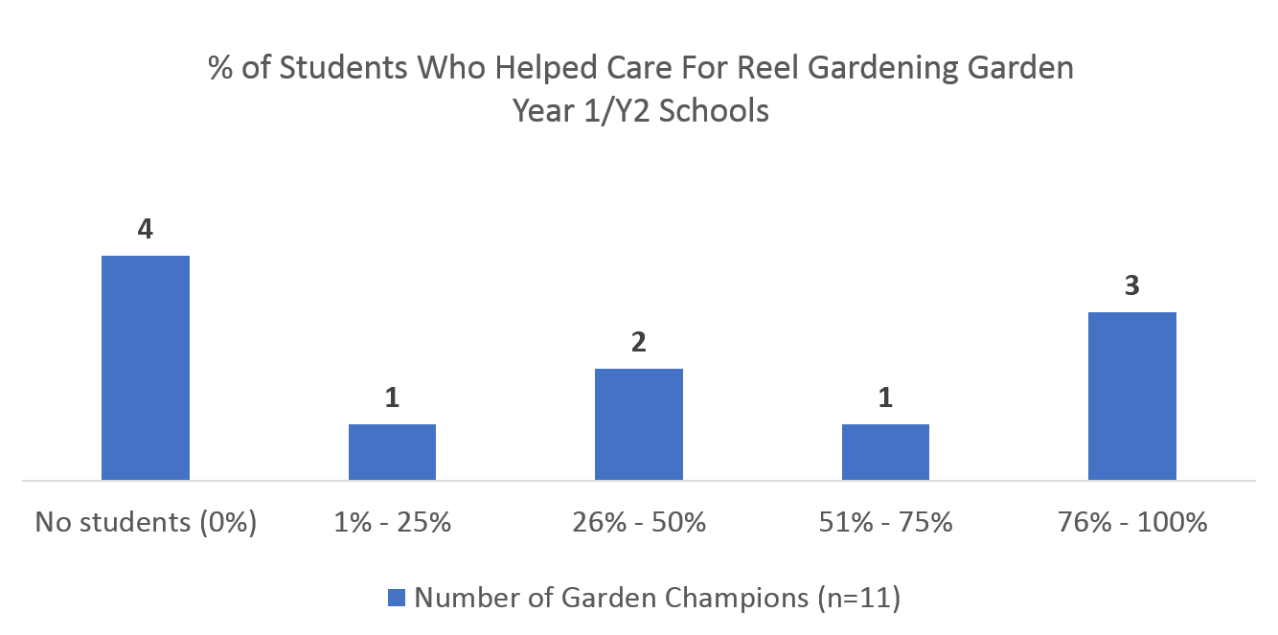

In addition, while the Reel Gardening gardens were primarily used to feed students, it was apparent in this research that vegetables from Reel Gardening gardens also benefitted those outside the student body, as illustrated in Figure 5. In this study, Kitchen Workers said that vegetables were donated to the elderly in a community, or to parents of students, or were sold to benefit the school. In addition, teachers sometimes ate the vegetables.

Figure 5. What happened to the vegetables grown in the Reel Gardening school garden (Y1/Y2)?
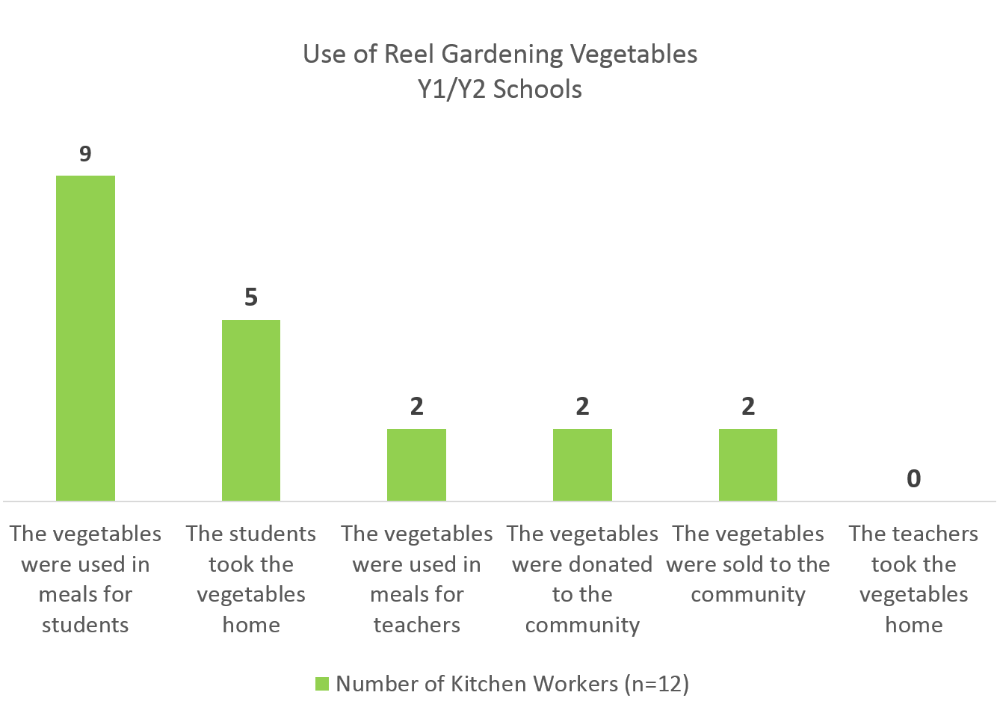

The term “low-income end-user” as used and calculated across all three years does not consider those outside the student body who may have eaten vegetables from the Reel Gardening garden, nor does it clarify other forms of benefits that students might have received, such as learning how to garden. If the term’s definition were to expand to include these components, then the number of low-income end-users counted could be raised. However, the degree to which more low-income end-users could be included is inconclusive from this study.

Year 3 Schools
There are various ways that Reel Gardening gardens benefitted Y1/Y2 schools in addition to school feeding: students caring for the garden, feeding the community, providing income to schools. However, given the scope of SWFF, these potential additional low-income end-users are not included in the final count.
Between Year 2 and Year 3, Reel Gardening shifted their business model to focus on the learning aspect of gardening rather than school feeding. Recent evaluation work and testimonials gathered by Reel Gardening indicate that students are excited to interact with the garden and that the teachers have been teaching the gardening curriculum. Of the four Y3 schools visited as part of fieldwork, 3 schools reported that the Reel Gardening curriculum had been taught. One school in the North West reported that it was “very effective” and that “students learnt how to do their own gardening.”

The learning focus is a newer development, and Reel Gardening will continue to focus on this model in upcoming years. In fact, a new curriculum unit was released in February 2018 and in upcoming months students will be given seed tape to bring home, to encourage them to plant their own gardens. However, the counting of low-income end-users for Y3 schools is currently limited to 6 students and does not consider the more widespread learning that is happening as an impact of note. While learning is harder to ascertain and quantify, it does appear to be a benefit of the Reel Gardening in Y3 schools.
Students in Y3 schools benefitted from the Reel Gardening program in terms of learning. However, given the scope of the SWFF program, this type of benefit is not counted among the low-income end-users.

- School Garden Consistency
All Years
The calculations for the total number of school garden low-income end-users are based on the full number of school programs ongoing during each school year (200 in Y1, 233 in Y2 and 2,232 in Y3). This assumes that all school gardens are in operation for the duration of the year. However, reports submitted by trainers throughout Y1 and Y2 indicate that not all schools were able to successfully implement the program. This phenomenon is also well-documented by Reel Gardening in Annual Reports. In addition, the majority of Y1 schools were not rolled out until the end of Y1. Though the program may have touched the reported number of low-income end-users at some point during the reported year, the low-income end-users numbers should include the caveat that the benefits were not consistent for all schools for the duration of the year.
Not all schools were able to maintain Reel Gardening gardens. Thus, it is likely that the benefits received from Reel Gardening gardens were not consistent throughout the school year.
TOTAL NUMBER OF LOW-INCOME END-USERS FOR HOUSEHOLD GARDENS
As SWFF reflects in its 2017 Annual Report, many of its innovators began with a focus on serving the poor, but shifted their focus to higher income segments of the population to obtain organizational sustainability. Reel Gardening is no exception to this trend, and the results of this shift can be seen in the data submitted on household garden end-users.

While the end-users of school gardens can be classified as low income, end users of household garden products are more difficult to classify. First, Reel Gardening has a few different customer profiles for household garden products. In the corporate customer category are organizations that purchase custom branded seed tape as gifts or giveaways, organizations that purchase units as donations, and companies that purchase products for retail resale. Individual customers can purchase through a few channels, including direct, online, or resale.

Reel Gardening retroactively indicated which household garden customers could be considered as low or low-middle income, and thus be counted as low-income end-users. Ipsos applied this categorization to product sales to determine how many household garden end users could be considered low-income end-users. These customers include a group of organizations (Nampak, AKTV, African Media Alliance and others) who purchased household garden products as part of their development projects, ensuring that end users are reliably in the BOP category. In addition, low-income end-users of household garden products also include recipients of seed tape donations in Y3 through the BOGO model.

TOTAL NUMBER OF FEMALE END-USERS
For all years, the reported percentage of female end-users is based on the national gender statistics for South Africa, which states that 51% of the population is female. Reel Gardening felt that because they could not count the number of female end-users accurately, the most efficient (and conservative) estimate was to assume that the use and benefit of Reel Gardening products followed the national average. Thus, they calculated that 50% of school end-users were female and 51% of household garden end-users were female.

In terms of school end-users, some Kitchen Workers reported that girls made up at more than 50% of students who ate vegetables from the Reel Gardening garden, as shown in Figure 6 below. While further conclusions cannot be drawn due to the small sample size, it does suggest that at some schools, girls received a disproportionate amount of vegetables, so Reel Gardening’s data may warrant a revision.

Figure 6. What percentage of students who ate vegetables from the Reel Gardening garden were girls?
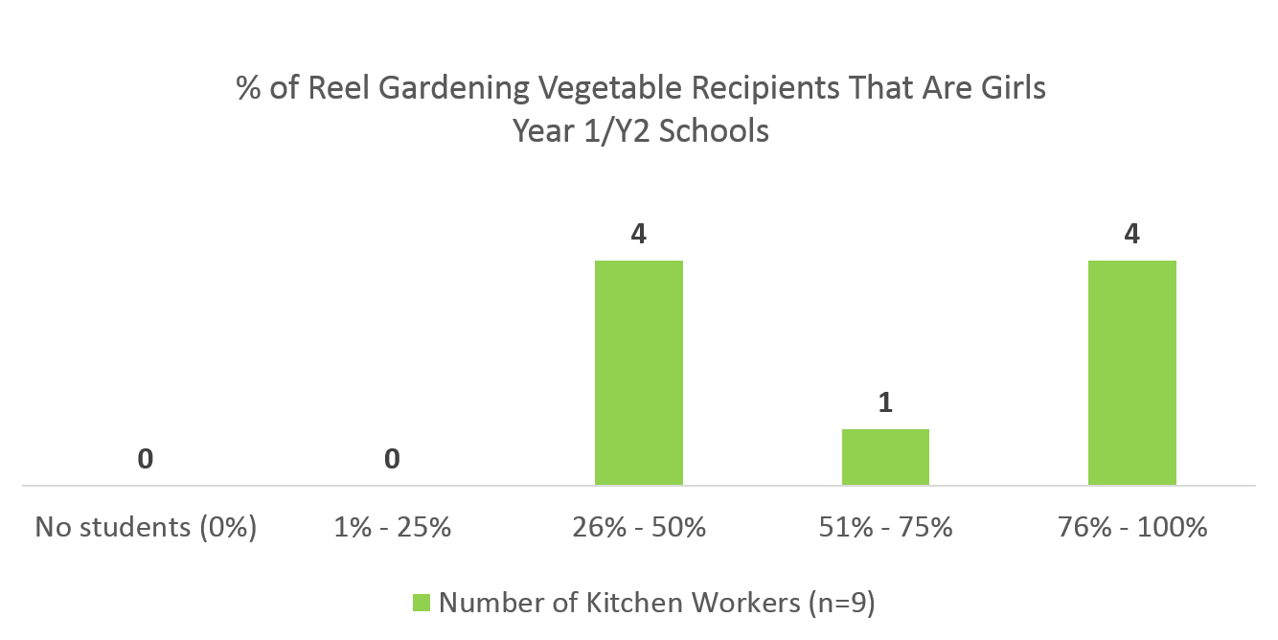

In addition, qualitative interviews with individual customers and a corporate customer who donated Reel Gardening products suggested that more women use the household gardening products than men. An analysis of product sales based on customer name reveals that approximately 70% of individual customers who bought Reel Gardening products were female. However, a customer interview did reveal that one product was bought as a present for someone else (male) so the above percentage should be mitigated by the fact that the gender of the end user cannot be accurately tracked.
The number of female end-users is likely higher than the 50% average estimated by Reel Gardening.
- HECTARES (HA) OF DELTA, ESTUARINE, OR AGRICULTURAL LAND (FIELDS, RANGELAND, AGRO FORESTS) IN PRODUCTION AS A RESULT OF SWFF INNOVATION
Assessing the area of land in production provides evidence for Evaluation Question 1 – the agricultural productivity targets, as well as Evaluation Question 3 – the impact of growing more food using less water. This indicator comprises the total amount of land that has been planted with Reel Gardening products.

Table 8. Summary of hectares of land in production
 | - Reel Gardening Data | - Summary of Findings
Year 1 | 26.40 ha | Evidence suggests that not all seed tape given to school or community gardens is planted. Thus, the figures for m² planted for Garden in a Box products have been decreased by 10%.
Year 2 | 14.09 ha
Year 3 | 10.09 ha

Reel Gardening estimated the total hectares of land in production by using product sales figures and calculating the total amount of seed tape in m² that was sold or given in that funding year. This m² figure was then divided by 1000 to reach hectares.

In terms of how total m² was calculated, each Reel Gardening product was first multiplied by the units of seed tape it contains, and then by the length of each individual seed tape strip (0.425 m), to obtain the linear meters of tape contained in each package. The linear meters of seed tape was then divided by 1.275 to account for the move from linear seed tape to m² of planted area.

Analysis of Reel Gardening data submitted for this indicator, as well as comparison to data from Ipsos, raised one point that was taken into consideration when calculating and validating the data relating to this indicator.

- Failure to plant all seed tape
The calculations for m² are based on the assumption that all seed tape given to school gardens was planted. However, findings from Ipsos data collection, shown below in Figure 8, suggest that in some schools, not all the seed tape was planted. In fact, of 10 responses, just 4 said that 100% of the seed tape was planted. Some Garden Champions explained that their garden space was too small at the school, or that they did not have enough volunteers to plant the garden.

Figure 7. What percentage of the seed tape received was planted?
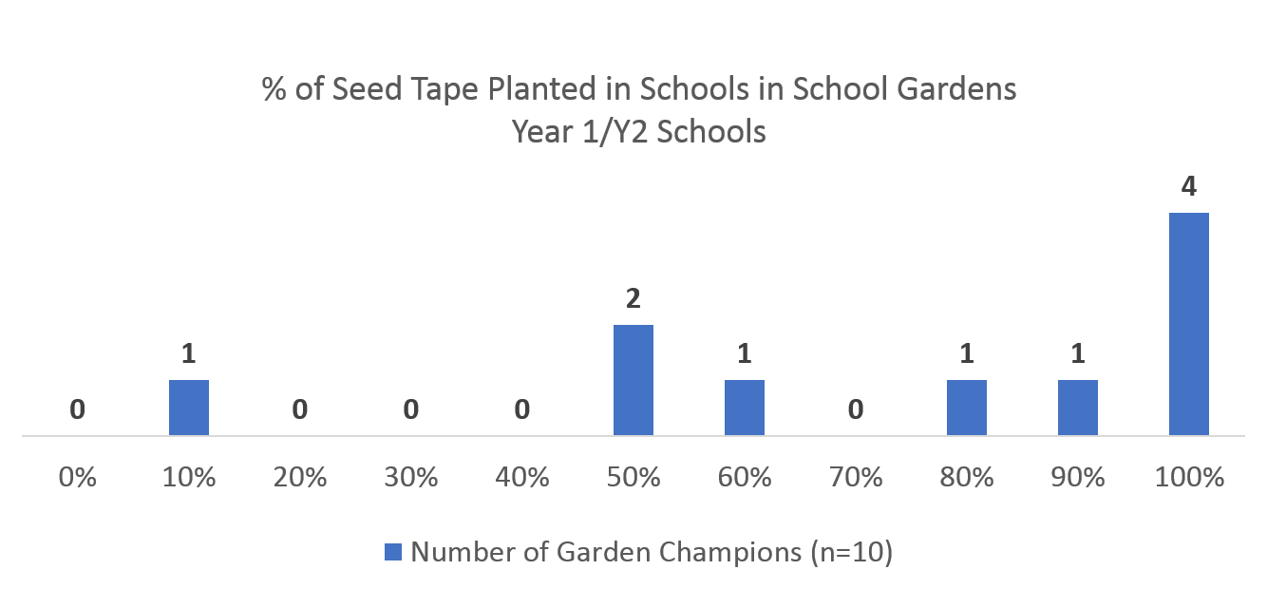

As most Garden in a Box sales for these years were given to program schools such as the ones sampled in the Ipsos primary data collection, the fact that not all seed tape was planted suggests that the total m² data is artificially high and the reported School Gardens area should be decreased to account for the failure of schools to plant all seed tape. Because of the small sample size of this study, a specific discount rate cannot be determined precisely.

In addition, by assuming that all seed tape given to school gardens is planted, then it would follow that at each Y1/Y2 school site, there would be 400 m² of land in production. Figure 8 below suggests that while some schools had planted gardens in the 400m², there are others that planted smaller gardens.

Figure 8. Approximately how much land was planted in total with Reel Gardening’s seed tape?
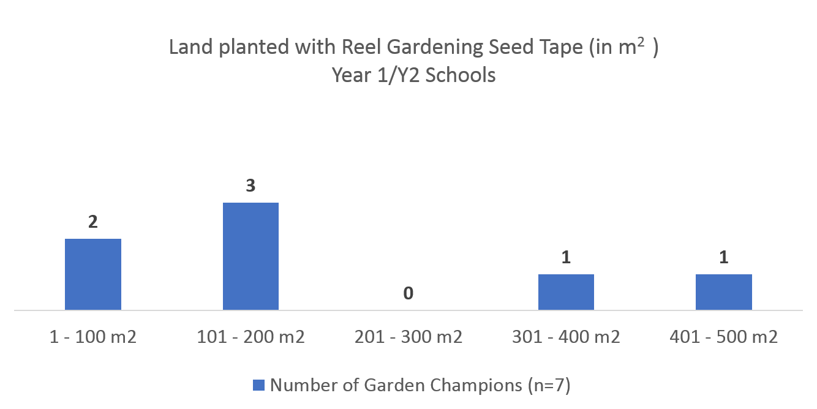

Evidence suggests that not all seed tape given to school or community gardens is planted and/or all school gardens are not 400m2. Thus, the figures for m² planted for school gardens should be decreased. Ipsos recommends a conservative discount of 10% to calculations of m2 to account for this fact. This reduction has been applied and the figures for this indicator include this reduction.
- VOLUME OF PRODUCE GROWN (IN KILOGRAMS)
Volume of produce grown, which is aligned with both Evaluation Question 1 – agricultural productivity - and Evaluation Question 3 – degree to which Reel Gardening grew more food – proved to be one of the most difficult indicators to accurately measure.

Table 9. Summary of volume of produce grown
 | - Reel Gardening Data | - Summary of Ipsos Findings
Year 1 | 441,432 kg | Evidence suggests that Reel Gardening calculations for Y2 and Y3 are likely a conservative, but valid, estimation. However, estimation methods are not consistent across all years and should be made so.
Year 2 | 200,141 kg
Year 3 | 148,643 kgs

Due to the retrospective nature of the study, Garden Champions were unable to remember with any consistency the amount of food they harvested from gardens, as many had not been maintained for over two years. In addition, even during the height of the Reel Gardening gardens, Garden Champions, and household garden users as well, did not make it a practice to measure or record the amount or weight of harvest. The nature and context gardening, unlike more formal agricultural innovations, does not often involve routine measurement of harvest. Rather, vegetables are picked on an ad hoc basis as they ripen.

With those limitations in mind, validation of the data Reel Gardening submitted to SWFF for this indicator relied on analysis of data from fieldwork combined with an investigation into the calculations used by Reel Gardening.

- Failure rate of vegetables
Because this metric is so difficult to accurately obtain from field reports, Reel Gardening must rely on assumptions about harvest. The most expedient way to employ assumptions about harvest is to apply a standard rate of kilograms of harvest per m2 of Reel Gardening product planted. For household garden products, Reel Gardening measured the average weight of vegetables over a m2 of seed tape planted, and then employed a 20% failure rate. For school gardens, Reel Gardening used past data from trainers, as well as the method used above, and assumed a failure rate of 40%. These methods yielded the following assumptions about the volume of produce grown from each m2 of seed tape. These assumptions were then multiplied by the number of m2 planted, with the discount rate applied, for each product.

Table 10. Assumptions on harvest
Type of Reel Gardening Product | Assumed Harvest per m2 of seed tape
School gardens | 0.73 kg/m2
Household gardens | 2.06 kg/m2

Data from the Ipsos evaluation validated that these assumptions represent reasonable, and even conservative, estimates. First, data from Ipsos shows that 7 of 12 Garden Champions reported that only some of the seed tape produced vegetables. Given this variation across schools, combined with the finding above that not all seed tape is planted, there is evidence that a failure rate should be included.

Figure 9. Approximately how much Reel Gardening seed tape that was planted produced vegetables?

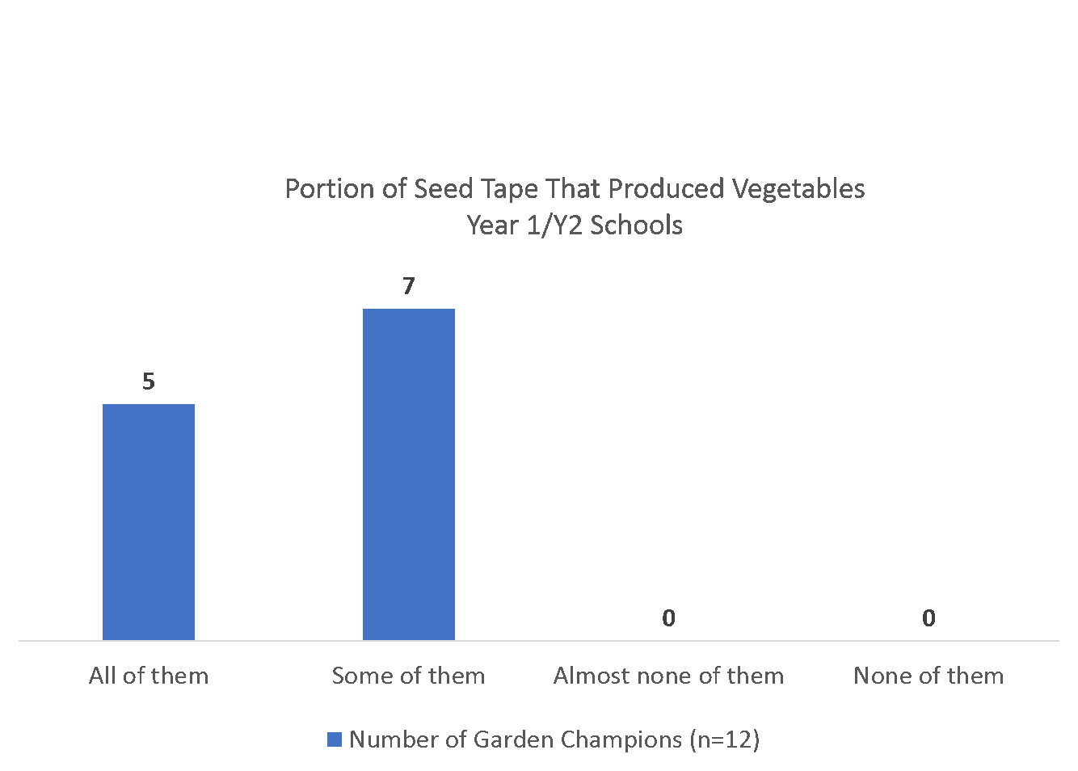

In Table 11 below, each vegetable provided in a 400m² Garden in a Box is analyzed according to the number of individual vegetables it would produce in one season (4 months). In the second column is the number of vegetables that would be produced under optimal conditions, assuming that all seed tape is planted and produces. The third column shows field data from this study for the average number of vegetables that Garden Champions reported their school gardens producing in one season. When these are compared to determine the failure rate for each vegetable, the average failure rate for all vegetables is 38%, very close to the 40% used by Reel Gardening in Y1.

Table 11. Number of vegetables grown in a season
Plant Type | Number of Plants in 400m² Garden in a Box Grown in 1 Season (4 months)  Optimal Conditions | Number of Plants in 400m² Garden in a Box Grown in 1 Season (4 months)  Average Reported by Garden Champions | % Failure Rate
Lettuce | 120 | 50 | 58%
Tomatoes | 60 | 62 | (2%)
Carrots | 640 | 234 | 63%
Beetroot | 320 | 190 | 41%
Spinach | 340 | 263 | 23%
Beans | 180 | 53 | 71%
Squash | 150 | 145 | 3%
Peas | 90 | 32 | 64%
Cabbage | 40 | 33 | 18%
AVERAGE |  |  | 38%

When a 40% failure is applied, this yields an average of 1.47 kg/m2 of vegetables grown, which is higher than the average used in school garden calculations (0.73 kg/m2) and lower than the average used in household gardens (2.06 kg/m2).

In terms of household gardens, Ipsos interviews with individual customers revealed that a 20% failure rate is also reasonable for those who bought their products directly or from a retailer. They explained that they felt that the seed tape helped them produce more vegetables than they had been able to with other traditional gardening methods, but that they still experienced failure due to weather and other external conditions, as well as user error.

Given that the failure rates for school gardens came from an examination of trainer records, coupled with the fact that Garden Champions had difficulty in recalling this information from 2 years prior during this study, the more conservative estimate for school gardens (0.73 kg/m2) used by Reel Gardening is likely a safer estimation of the actual volume produced. Conversely, given the information gleaned about household gardens, and the fact that end users are different than those at school gardens, the higher average of (2.06 kg/m2) is likely more accurate.
Evidence suggests that Reel Gardening calculations for volume of produce are likely a conservative, but valid, estimation.
In addition, for schools that have a current (non-Reel Gardening) garden, most Garden Champions expressed that the Reel Gardening garden had produced more vegetables than the current one. Thus, despite the failure rate, Reel Gardening gardens still provided a means for schools to grow more vegetables for more students.

Figure 10. Compared to the current school garden, do you think the Reel Gardening garden produces more, less or the same amount of harvest?

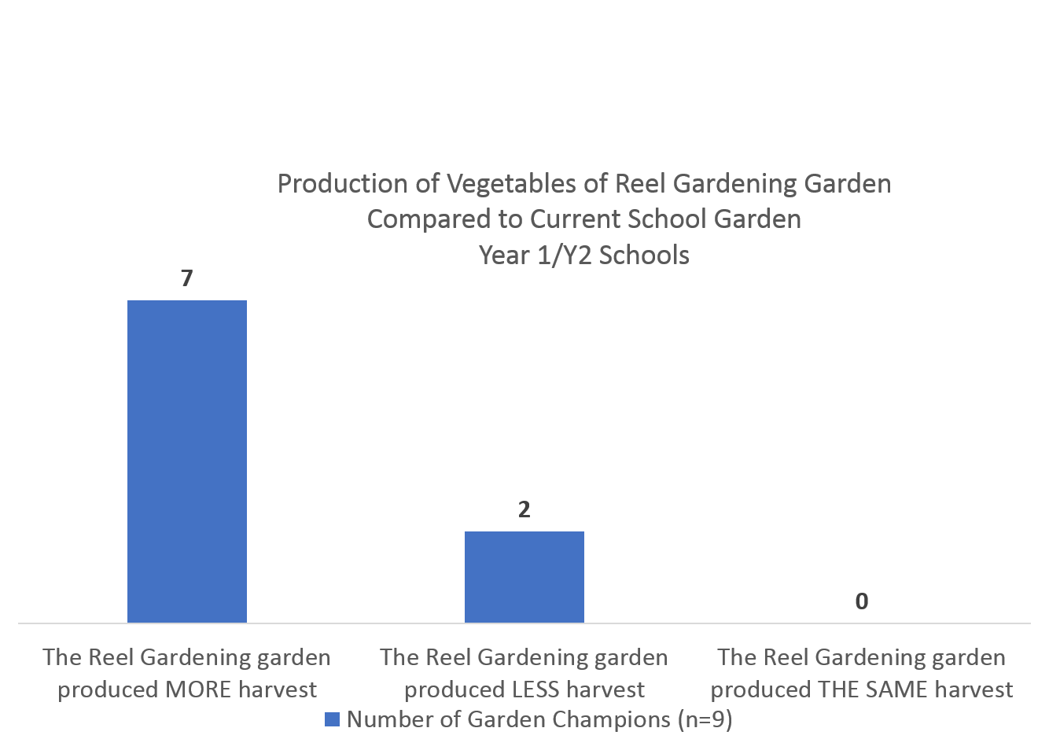

- AGRICULTURAL WATER CONSUMPTION REDUCTIONS (BY VOLUME IN LITERS) AS A RESULT OF SWFF INNOVATION
Like volume of produce grown, agricultural water consumption is another indicator that is difficult to measure in field and must rely on assumptions about amount of water use multiplied by other variables such as area of land in production. While this is an imperfect method, it is the most expedient and cost-effective way to estimate this indicator, given the context of Reel Gardening’s work.

Table 12. Summary of agricultural water consumption reduction (in liters of water saved)
 | - Reel Gardening Data | - Summary of Findings
Year 1 | 23,936,068 liters | While it is difficult to validate this number given the limitations of this study, evidence suggests that Reel Gardening gardens used less water than other methods. However, while the estimation used by Reel Gardening may be conservative, there is not enough evidence to recommend any revisions.
Year 2 | 12,771,881 liters
Year 3 | 8,406,495 liters

To calculate this, Reel Gardening ascertained water consumption for number of liters used per m² per week traditional gardening methods and compared that to an assumption about Reel Gardening users’ water use.

The estimation for traditional methods was made by taking average water use from several published studies, resulting in a figure of 26.1 liters/m²/week or 3.73 liters/m²/day. Reel Gardening then multiplied this by the total m² of seed tape used (with the discount rate applied), and then multiplied this by 6 weeks, to obtain the total number of liters that would have been used on all Reel Gardening land in production over a 6-week period if traditional gardening methods had been used.

To calculate the water used for Reel Gardening products, the same method as above was used, but the assumptions for water use per m² were derived from a combination of data from trainer reports and experiments conducted in office. Trainers had provided data on method of watering, and the number of watering cans used, or time hosepipes were used by Garden Champions. Reel Gardening averaged these results and then conducted office experiments to help estimate the total volume of water used in Reel Gardening school gardens. The final results of the Reel Gardening calculations assumed that all watering cans contained 10 liters of water and that one minute of hosepipe use consumed 7 liters of water. The final calculation of water consumption was estimated at 1.57 liters/m²/day.

When Garden Champions were asked in the survey to estimate their water use on the Reel Gardening gardens, data yielded an average of 0.36 liters/m²/day when the same usage assumptions as the Reel Gardening estimate were used (i.e. the size of a water can is 10 liters and one minute of hosepipe use consumes 7 liters of water). The difference in these figures is due to Reel Gardening assuming that gardens were watered more frequently than reported by Garden Champions in this study. While remembering the precise number of times that they watered the Reel Gardening garden each day or week is difficult for Garden Champions, especially when asked retrospectively, it is possible that Reel Gardening took too conservative an estimate on the amount of water used, and in fact, Garden Champions used less of it than assumed. When asked if they had enough water to care for the Reel Gardening garden, most Garden Champions replied yes, but 2 of 12 said no. This could possibly indicate that they did not water the garden to the optimal amount, thus using less water.

Figure 11. Method of Watering Reel Gardening gardens

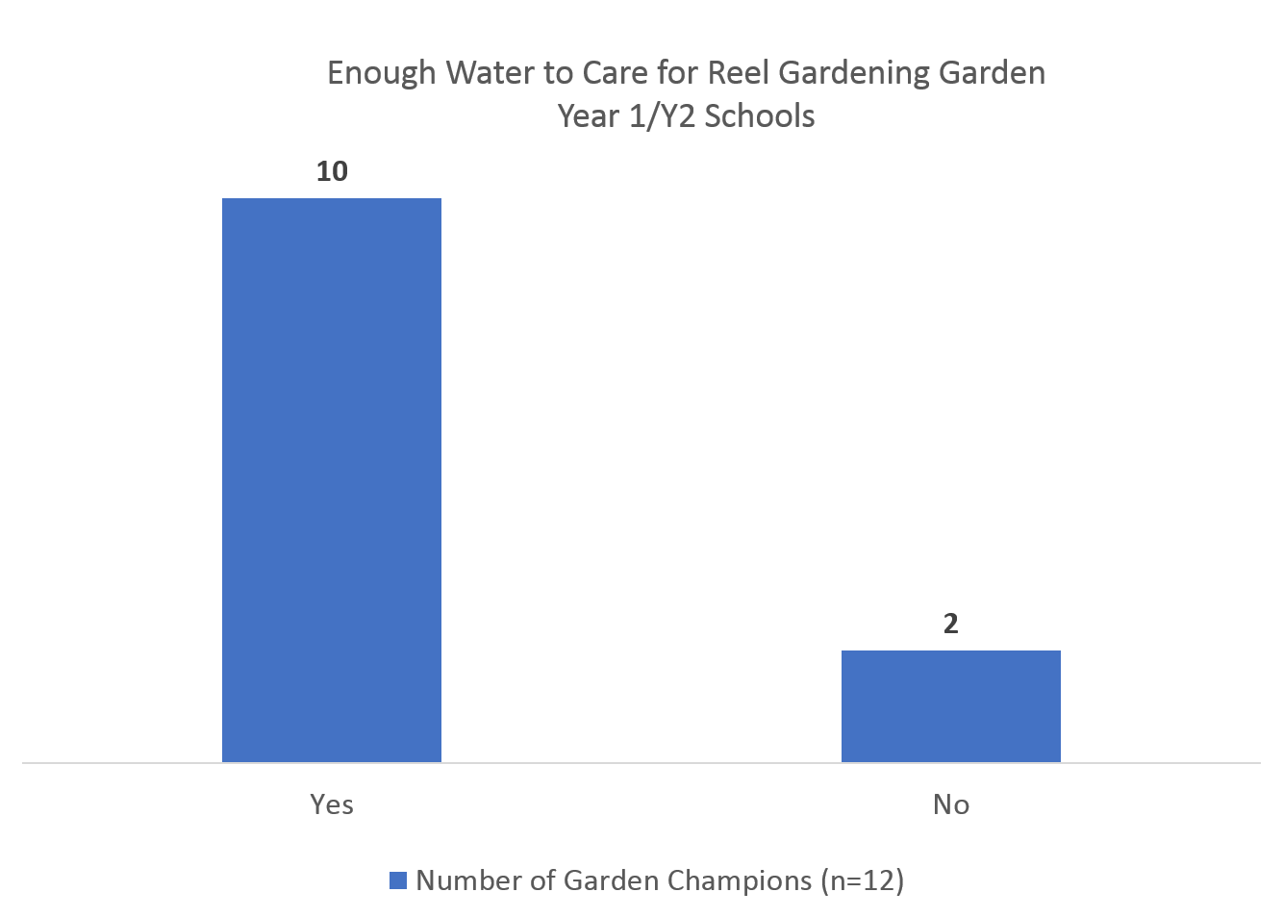

It should be noted that in Y3, Reel Gardening only included USAID accepted end-user data, which reduced the number of end-users and accordingly, the total volume of water saved.

When asked to compare water usage generally, most Garden Champions reported that the Reel Gardening garden requires less water than their current school garden, further validating the Reel Gardening claim that their seed tape innovation leads to water reduction.
Figure 12. Compared to the current school garden, do you think the Reel Gardening garden requires more, less or the same amount of water?

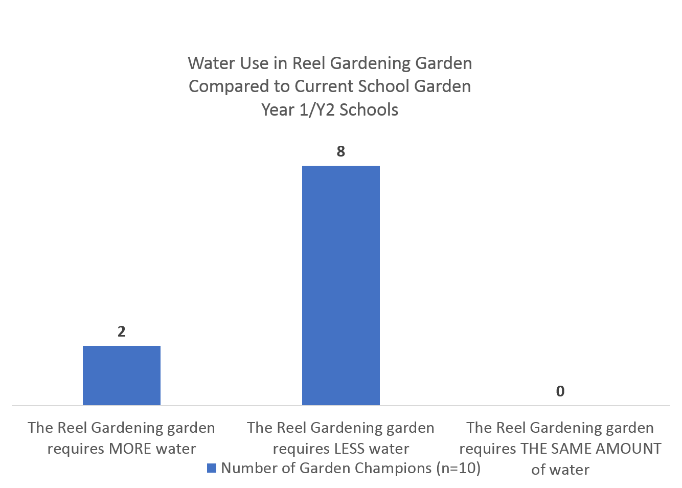
Though it is difficult to validate this number given the limitations of this study, evidence suggests that Reel Gardening gardens used less water than other methods. While the estimation used by Reel Gardening may be conservative, there is not enough evidence to recommend revisions.

FINDINGS: FINANCIAL INDICATORS

The three metrics in the table below comprise the group of financial indicators for which Reel Gardening submitted data to SWFF. These indicators speak to Evaluation Question 4 (local demand for product) and Evaluation Question 6 (sustainability of the organization). While the technical indicators above are helpful in assessing the extent to which Reel Gardening met SWFF’s goals of producing more food using less water, these financial indicators give a sense of the overall sustainability of Reel Gardening as it exits the SWFF program cycle.

Findings for this portion of the evaluation were informed by Ipsos qualitative interviews and the desk review of Reel Gardening documents, both of which provided insight on the larger question of Reel Gardening’s future sustainability. Because these three indicators are focused towards the same goal – the sustainability of Reel Gardening - they are presented together.

Table 13. Summary of financial indicators
 |  | - Reel Gardening Data | - Summary of Findings
Value of sales (collected at farm-level) attributed to SWFF innovation | Year 1 | $18,087.23 | Reel Gardening is well on its way to achieving financial stability and eventual profitability, which will allow them to finance their operations entirely through sales rather than funding.
 | Year 2 | $128,668.14
 | Year 3 | $83,839.81
Total Matching Funds | Year 1 | $334,516.34
Total Matching Funds | Year 2 | $251,640.72
Total Matching Funds | Year 3 | $250,000.00
Percentage of gardens re-purchased/re-planted | Year 1 | 20%
Percentage of gardens re-purchased/re-planted | Year 2 | 38%
Percentage of gardens re-purchased/re-planted | Year 3 | 41%

The calculations for these indicators are based on the product sales found in the Milestones Spreadsheets. The figures above assume that all product sales have been recorded correctly. To fully verify this assumption, a full audit of each sale would be required, which is beyond of the scope of this study. However, interviews with Reel Gardening founder Claire Reid, combined with Ipsos spot checks of Reel Gardening financial reports, were sufficient to conclude that the Milestone Spreadsheets include a full accounting of all product sales.
This study recommends no revisions to the data submitted by Reel Gardening on financial indicators and considers them valid given current knowledge.

- Increase in unique sales
To understand Reel Gardening’s potential for sustainability, it is important to keep the business model shift in mind. As Reel Gardening transitions to an approach that emphasizes commercial, profitable sales of its products, we should expect to see an increase in the value of sales over this time period, as they focus efforts on discovering new pipelines for sales opportunities.

As Reel Gardening has increased the total value of their sales from Y1 to Y3, it seems that they have been able to achieve this. In terms of unique sales, Reel Gardening increased these each year, from 132 in Y1, to 234 in Y2 to 272 in Y3. The new sales in Y3 includes several larger retail outlets such as Food Lover’s. These types of sales are still new to the organization, but as Reel Gardening finalizes their business model pivot and gains more experience selling in retail outlets and directly to customers online, they should continue to find more large retail customers such as these.

Reel Gardening has also become more strategic about their sales strategy. Sattva, an advisory and implementation firm tasked by the SWFF TA to consult on Reel Gardening’s business model shift, explained that in Y1, Reel Gardening did not have a solid understanding of their customer nor a fully operational business plan in place. After working with Sattva, they were able to begin to strategically implement their new BOGO model and Sattva feels that they are well on their way towards meeting their targets for sales.

- Decrease in dependence on matching funds
Reel Gardening has seen a decrease in its dependence on matching funds. In Y1 they were approximately 90% dependent on Unilever funding. As mentioned above, 85% of total end users in Y1 were a result of Unilever support – custom seed tape products bought by Unilever.
However, Reel Gardening has been able to reduce dependence on Unilever funds that to about 40% - 50% in subsequent years. As Reel Gardening wins new bulk customers, as well as online individual customers, they will depend less on matching funds to sustain the BOGO component of their business model. This points to the ability of Reel Gardening to eventually become completely self-sufficient.

- Customer enthusiasm and loyalty
Financial data show an increase in the number of products re-purchased from Y1 to Y3. In addition, Ipsos’ qualitative interviews with both corporate customers and individuals revealed that in general, customers are happy with their purchases and are willing to repurchase. Unilever continues to renew their partnership and create new avenues to use Reel Gardening products. The representative from Unilever interviewed by Ipsos explained that they are excited about new collaborations and believe that there is a local demand for these products. Further, these new collaborations indicate Unilever’s belief in the mutual benefit to come from these initiatives, and that their company will profit through programs with Reel Gardening.
Further, Unilever’s willingness to embark upon new business relationships with Reel Gardening shows good faith in their ability to appeal to customers and profit potential for Unilever through Reel Gardening products. Unilever’s interest in this relationship and selection of Reel Gardening for this partnership stemmed from a desire to drive social impact through product growth, suggesting that they have strong confidence in the Reel Gardening products, message, and business overall.

- Positive feedback from Sattva
An Ipsos interview with a representative of Sattva, the group that designed Reel Gardening’s business and scale-up plan and BOGO model was particularly informative as to the sustainability of Reel Gardening. This representative has worked with multiple SWFF innovators and conveyed an overall positive impression of the changes that Reel Gardening has implemented as to align with the recommendations of the business plan. The business plan helped segment Reel Gardening’s target buyers to identify where to make the greatest impact through sales, leading to greater financial security, through which the BOGO model could be implemented without collapse. According to this representative’s perspective, Reel Gardening is well on its way to achieving financial stability and eventual profitability, which will allow them to finance their operations entirely through sales rather than funding.

ADDITIONAL FINDINGS NOT COVERED IN EVALUATION QUESTIONS
While the primary aim of this evaluation was a validation of impact data submitted by Reel Gardening to SWFF, the evaluation also uncovered an area of impact that has not yet been discussed.

While gardening is common across South Africa, and while many schools already maintained school gardens prior to Reel Gardening, data from fieldwork indicates that Reel Gardening helped to start gardens in schools that previously didn’t have gardens. For example, in the Y1/Y2 schools, Reel Gardening started the first garden in 5 of 12 schools (the rest had previously had school gardens). Of those 5 schools with new school gardens introduced by Reel Gardening, all of them currently have a garden. Despite Reel Gardening programming having stopped in these schools in 2016, they have continued to maintain these gardens. This speaks to Reel Gardening’s impact on creating gardens in places that otherwise wouldn’t have them, and inculcating a school culture of gardening.

In addition, the findings from Ipsos interviews with individual customers as well as both Unilever and Sattva representatives indicate that Reel Gardening products draw customers that would not otherwise be gardening, indicating an expansion of audience beyond those that already have an interest in gardening. Thus, Reel Gardening has been able to create new garden sites and new gardeners throughout South Africa.

Conclusions & Recommendations

EVALUATION QUESTION 1: DID REEL GARDENING MEET THEIR AGRICULTURAL PRODUCTIVITY TARGETS BASED ON EVIDENCE FROM THIS EVALUATION?
Agricultural productivity was assessed according to the area of land in production and the volume of produce grown. These indicators, like others, were based on optimal conditions – that is, all of the seed tape given or sold to end users was used in its entirety. Fieldwork suggested that not all seed tape, either for school garden or household garden products, was used and that the final numbers submitted by Reel Gardening may need to be reduced. However, estimations for volume of produce grown aligned with findings from fieldwork and suggested that Reel Gardening may have been too conservative in this estimation.

There is sufficient evidence to suggest that Reel Gardening met the intent of SWFF goals in agricultural productivity in Y1 and Y2. Despite the widespread and well-documented problems that plagued the school roll out in these years, Reel Gardening gardens were able to produce vegetables in program schools. In terms of Y3 productivity, it should be noted that agricultural productivity is not the goal of the program in Y3. Rather, learning and gardening skills are, at least through the school roll out program.

EVALUATION QUESTION 2: TO WHAT DEGREE DID REEL GARDENING INCREASE WATER EFFICIENCY THROUGH THE SEED TAPE AS COMPARED TO TRADITIONAL SOUTH AFRICAN GARDENING PRACTICES?
With the knowledge at present, the data submitted by Reel Gardening is considered valid. Thus, it can be concluded that Reel Gardening gardens helped to save water as compared to traditional gardening methods. This was especially true for school gardens, where large (400m²) gardens were being maintained.

Evidence suggests that the estimation used by Reel Gardening to calculate the water usage of Reel Gardening gardens (as well as traditional methods) is reasonable, and even conservative, though precise validation within the scope of this study is challenging. To better measure this indicator in the future, stronger monitoring systems must be put in place or a more comprehensive study involving current schools must be conducted.

Evaluation Question 3 is considered covered under Evaluation Questions 1 and 2.

Evaluation Question 4 is considered covered under Evaluation Question 6.

EVALUATION QUESTION 5: TO WHAT DEGREE DO VULNERABLE GROUPS (THE POOR, WOMEN, ETHNIC MINORITIES) IN SOCIETIES BENEFIT (INCOME, EMPLOYMENT, WATER) FROM THE REEL GARDENING SEED TAPE VERSUS OTHER AVAILABLE ALTERNATIVES?
Overall, Reel Gardening positively impacted vulnerable groups in South Africa by providing vegetables. There is evidence to suggest that Reel Gardening was able to supplement meals for students through its school feeding scheme.

Calculating the total number of low-income end-users for Reel Gardening programs was a complex process that should be revised on several fronts. First, SWFF and Reel Gardening should more clearly define what constitutes a low-income end-user and how reports in each year treat low-income groups versus end users who are middle or high income.

EVALUATION QUESTION 6: TO WHAT DEGREE IS THE SEED TAPE LIKELY TO BE SUSTAINABLE UNDER THE REEL GARDENING ORGANIZATION?
Reel Gardening has made important strides in achieving sustainability, primarily through finding new, high-volume customers as well as lowering their dependence on matched funding. The switch to the BOGO business model is still in its infancy, but stakeholders are confident that Reel Gardening is willing and able to take the steps necessary to achieve sustainability.

OVERALL CONCLUSIONS & RECOMMENDATIONS
While Reel Gardening is to be commended for the comprehensive nature of their records and their attempts to deliver thorough monitoring systems in a challenging environment, they may be able to create simpler and more transparent record-keeping approaches in the future. In order to accurately compare figures, Ipsos had to adjust Reel Gardening’s data to ensure that consistent methods were applied across program years.
A driver in the complexity of records and occasional inconsistencies between program years is the fact that Reel Gardening is, by nature and inclusion in the SWFF portfolio, an innovative project that is necessarily changing key aspects about its model. Thus, indicators and targets devised at the beginning of a project may no longer apply as the project changes. While SWFF provided flexibility in terms of adjusting targets for pre-determined indicators, fundamental issues such as the definition of total versus low-income end-users became misaligned by the time Reel Gardening implemented its new model in Y3.

An initial resolution was found in revising past data to ensure consistent approaches across years, but a larger conversation around the parameters of indicators and how they apply to changing projects is recommended.

However, given the scope of the evaluation questions above and the findings on each aligned indicator, it can be concluded that while the data submitted by Reel Gardening needed some revisions, based on available evidence they have achieved their stated impact on the SWFF goals of producing more food using less water.

Annexes

Annex I: Evaluation Statement of Work
Business Need
Reel Gardening is a SWFF Round 1 innovation that has come to the end of its program life cycle and requires a performance evaluation to validate the impact data that Reel Gardening has submitted to SWFF (entailing document reviews, end-user interviews, etc), and to investigate and evaluate previously inaccessible data from local stakeholders whose impact has not been adequately surveyed. Securing Water for Food, through USAID, will use this evaluation as a final determinant of the success of the Reel Gardening award. In addition, the results of this performance evaluation will contribute to a larger SWFF program performance evaluation from 2018-2020 as well as to the evidence available on the US Global Development LAB’s portfolio of innovation.
Summary Strategy/Project/Activity/Intervention to be evaluated
The Reel Gardening model claims to have a profound and combined impact in the fields of nutrition, education, income, water conservation and entrepreneurship for low-resourced communities. From the beginning, Reel Gardening has been a company dedicated to serving the poor by providing them the means to produce healthy produce at low cost. They have done this most directly by working with schools across South Africa to implement school gardens and guiding them in the ongoing management of the gardens. The funding for these school gardens has come largely through a partnership with Unilever and other South African corporations utilizing Corporate Social Investment (CSI) money.
During Year 1 of their SWFF award, Reel Gardening hypothesized that supplying schools with 400m2 Garden in a Boxes, could:
- Impact the quality of food that was supplied to learners through the school feeding scheme.
- Catalyze sales of Reel Gardening to the community involved with and surround the targeted schools
Reel Gardening produced a series of lesson plans and worksheets designed to fit the South African curriculum, hoping to encourage teachers to become future customers. Often the only meals that learners receive in a day are provided through this program. As such, providing a nutritious meal supplemented with fresh vegetables will have an impact on the devastating levels of malnutrition in South Africa.
These school gardens were also used as an outdoor classroom. A 400m2 garden, the average amount of land available for planting at schools, was not intended to feed an entire school sustainably. However, it was supposed to be used to teach the whole school how to grow food. They also trained agents to conduct all the necessary training to equip “garden champions” at each school to care for their new garden effectively and to guide them through their first growing cycle. These same agent/trainers were stocked with a micro-consignment of Reel Gardening seed tape in order to equip them to meet local demand for the product through their own micro-businesses. However, by the end of Year 1 it became clear that school-referred buyers were not materializing. Based on feedback from schools and trainers, Reel Gardening believes that a combination of factors were at work. In many schools, key leaders were not invested in the success of the garden. As the schools targeted were low income, many potential buyers were not willing to buy the seed tape (which are more expensive than the seeds alone), and were accustomed to receiving agricultural supplies for free through aid programs.
From Year 2 of the project onwards, Reel Gardening has been pivoting to a strategy that emphasizes commercial, profitable sale of its products in order to use a portion of profits to subsidize its work with schools and other beneficiaries. This serves the dual purpose of continuing to impact the intended beneficiaries, while reducing its dependence on corporate partnerships for funding and revenue. As part of this shift, Reel Gardening, with support from the SWFF TA Facility, developed a Buy One Give One (BOGO) component for its business model making strong progress towards a dual social enterprise model in which the profit-making entity funnels profits to support the local communities that cannot afford the seed tape. Reel Gardening started rolling out this Buy One Give One scheme in May 2017, with the first retail partnership commencing in the USA through The Girl Scouts of America. For all Reel Gardening product sold in a retail environment moving forward, Seed tape will be donated to schools and communities within South Africa to further Reel Gardening’s positive social impact at the BOP level in a sustainably funded manner.
This gradual progression in Reel Gardening’s approach to community development as well as the evolution of Reel Gardening’s business model through the support of the technical assistance facility (TAF) has changed Reel Gardening’s strategy and targets within SWFF. Reel Gardening now has a clear strategy and road map for implementation in the form of a ‘Play Book’ that was developed through the TAF. This Playbook has now, in the past two months, been completed and Reel Gardening is ready to begin implementing the recommendations within the organization.
The end-users of the Reel Gardening Project are:
- The agent/ trainers equipped with the skills and resources to conduct vegetable garden training at schools as well as start their own micro-businesses by selling Reel Gardening seed tape
- The community members, parents, teachers and learners directly trained by Reel Gardening agents to care for the school gardens
- The learners dependent on the school feeding schemes who eat the vegetables grown at the schools
- The learners who are taught to grow their own food through interaction with the school garden and utilization of the Reel Gardening School Worksheets
- The customers who, through their interaction with the donated school garden, purchase Reel Gardening seed tape to enable them to grow their own food with limited water
- The consumers who receive promotional Reel Gardening products through custom-branding campaigns (such as those who purchased Unilever “Rajah” brand products)
SWFF will provide the external evaluator with Reel Gardening’s data that were collected on a semi-annual basis. SWFF’s M&E processes enable timely and consistent collection of comparable performance data in order to make informed program management decisions. SWFF will also provide the external evaluator with Reel Gardening’s Acceleration Workplans.
Evaluation Questions
The performance evaluation sought through this RFP should determine whether or not the use of Reel Gardening’s seed tape led to the production of more food using less water. During this evaluation, the evaluator will examine evidence provided to SWFF by SWFF awardees in order to determine the impact of the program around the following questions:
What is the magnitude of the effect that Reel Gardening has on its intended outcomes and results as outlined by certain pre-determined indicators and including the following areas:
  - To what degree did Reel Gardening have the demonstrated impact of growing more food using less water for the target groups as noted in its milestones and the evidence provided to SWFF?
  - To what degree is there demand for and local ownership of Reel Gardening seed tape?
  - To what degree do vulnerable groups (the poor, women, ethnic minorities) in societies benefit (income, employment, water) from the Reel Gardening seed tape versus other available alternatives?
  - To what degree did Reel Gardening increase water efficiency through the seed tape as compared to traditional South African gardening practices?
  - To what degree did Reel Gardening lead to more agricultural productivity and resilience to climate change as compared to traditional gardening practices in South Africa?
  - Did Reel Gardening meet their agricultural productivity targets based on evidence from this evaluation?
  - To what degree is the seed tape likely to be sustainable under the Reel Gardening organization?
Evaluation Design and Methodology
SWFF expects that the evaluator will conduct the following in this performance evaluation:
- Review of historical & projected financials and other existing SWFF data
- In-depth meetings with management team to review business model and historical data
- Field visit to the manufacturing facility (approximately 2-day visit)
- Interviews with vendors, supply chain stakeholders, and/or competitors
- Interviews with corporate bulk-purchasing customers (minimum 5, prioritized according to the amount of seed tape purchased)
- Interviews with customers and non-customers (minimum 15) (minimum 5)
- Interviews with schools (minimum 28) and other organizations that have received the Reel Gardening seed tape through donations
- Validation of theory of change
- Review report(s) summarizing all meetings held, information gathered, and analysis conducted
The following table outlines key questions to be answered during evaluation:
Questions |  |  | Suggested Data Sources (*) |  |  | Suggested Data Collection Methods |  |  | Data Analysis Methods
1. To what degree did Reel Gardening have the demonstrated impact of growing more food using less water for the target groups as noted in its milestones and the evidence provided to SWFF? |  |  | Documents (including. performance monitoring data), national statistics, project staff, stakeholders, expert knowledge, end-users |  |  | Key informant interviews (in particular corporate purchasers), questionnaires or surveys, focus group discussions, direct observation, desk review |  |  | To be determined by evaluation team  Requested level of disaggregation— gender, income level, location (district, province)
2. To what degree is there demand for and local ownership of Reel Gardening seed tape? |  |  | Documents (site visit report), project staff, stakeholders, end-users |  |  | Key informant interviews, questionnaires or surveys, focus group discussions, desk review |  |  | To be determined by evaluation team  Requested level of disaggregation— gender, income level, location (district, province)
3. To what degree do vulnerable groups (the poor, women, ethnic minorities) in societies benefit (income, employment, water) from the Reel Gardening seed tape versus other available alternatives? |  |  | Documents (including performance monitoring data), national statistics, project staff, stakeholders, expert knowledge, end-users |  |  | Key informant interviews (in particular corporate purchasers), questionnaires or surveys, focus group discussions, direct observation, desk review |  |  | To be determined by evaluation team  Requested level of disaggregation— gender, income level, location (district, province)
4. To what degree did Reel Gardening increase water efficiency through the seed tape as compared to traditional South African gardening practices? |  |  | Documents (Reel Gardening records from trainers), national statistics, project staff, stakeholders, expert knowledge, end-users |  |  | Key informant interviews, questionnaires or surveys, focus group discussions, direct observation, desk review |  |  | To be determined by evaluation team  Requested level of disaggregation— corporate customers vs. schools vs. private customers
5. To what degree did Reel Gardening lead to more agricultural productivity and resilience to climate change as compared to traditional gardening practices in South Africa? Did Reel Gardening meet their agricultural productivity targets based on evidence from this evaluation? |  |  | Documents (Reel Gardening records from trainers), national statistics, project staff, stakeholders, expert knowledge, end-users |  |  | Key informant interviews, questionnaires or surveys, focus group discussions, direct observation, desk review |  |  | To be determined by evaluation team  Requested level of disaggregation— corporate customers vs. schools vs. private customers
6. To what degree is the seed tape likely to be sustainable under the Reel Gardening organization? |  |  | Documents (including performance monitoring data, Reel Gardening financial records), national statistics, project staff, stakeholders, expert knowledge, end-users |  |  | Key informant interviews, questionnaires or surveys, expert knowledge, desk review |  |  | To be determined by evaluation team

Annex II: Evaluation dEsIGN
Introduction
This evaluation approach for the Reel Gardening Evaluation was based on the information gathered through the review of program documentation, stakeholder interviews and a scoping visit in February 2018. The Ipsos team expects that further conversations with Reel Gardening and SWFF, and a site visit in February 2018, will yield further insight and details about the Reel Gardening Program that will inform the final evaluation approach.

Program Logic and Evaluation Questions
Reel Gardening is a South Africa-based innovation supported by SWFF. Reel Gardening has developed a unique seed system that they claim can be grown into a vegetable or herb garden in nearly any climate.

The purpose of this evaluation is to validate program performance data submitted by Reel Gardening on behalf of SWFF/USAID. The primary research questions and indicators are therefore drawn from SWFF’s framework and stated research interests (see “Evaluation Matrix” below). However, understanding Reel Gardening’s program logic through a theory of change is helpful in thinking through a valid evaluation approach to offer more holistic feedback on program performance. Table 1 illustrates the evolution of Reel Gardening’s model.

Table 1

Reel Gardening has tested multiple program delivery approaches since its inception in 2015, and ultimately settled on a Buy One-Give One (BOGO) business model for product distribution in 2017. This transformation is relevant to the evaluation approach, as the end users, both paying customers and beneficiaries, have changed during this time. In Year 1, end users were Garden Champions, students and communities at school garden sites who benefitted from food produced by the garden, as well as agent/trainers who benefitted from selling seed tape as a micro business and individual beneficiaries who receive household gardens.

The end users of the new business model in Year 3 include corporate customers who buy in bulk, private customers who buy retail products, students in partner schools who learn about gardening, teachers in partner schools who teach their students about gardening and individual beneficiaries who receive household gardens as part of the BOGO model.

Evaluation Matrix
In Table 2 below is a matrix that links the Evaluation Questions as outlined by SWFF in the RFP dated August 28 to the process through which it will be verified. Under each Evaluation Question we consider the outcome indicators and metrics, the aligned data sources submitted as evidence from Reel Gardening/SWFF, the data sources from Ipsos’ evaluation that will be used for the validation, the plan for analysis, and any challenges or other considerations worthy of note.

For the verification process, Ipsos also intends to review the records, such as invoices, delivery notes and MOUs during the site visit, if possible. Starred (*) sources indicate documents or records that we have not yet received or reviewed.

Table 2
Evaluation Question 1 - Productivity
Did Reel Gardening meet their agricultural productivity targets based on evidence from this evaluation?
Indicator | Reel Gardening Data |  |  | Ipsos Validation Data |  | Analytical Approach | Considerations
Area of land in production | Use data sources attached to indicators below from questions below |  |  | Interviews and surveys with broadly representative sample of customers and low-income end-users |  | Examine milestones achieved for Years 1 ,2 and 3. Consider submitted milestone data as well as data from validation exercise. | End users may not be able to give precise yields because of recall and accuracy issues.
Volume of produce grown | SWFF AWPs, RG Overall Indicator Achievement Trainer Geo Maps reports. |  |  | Interviews with Garden Champions, teachers and household garden end-users |  | Estimate the volume of produce grown, in consideration of optimal rate from Evaluation Question 1. Compare to Reel Gardening submitted data. | Must make estimations about quality of figures submitted by Reel Gardening rather than validating with exact percentages
Evaluation Question 2 - Efficiency
To what degree did Reel Gardening increase water efficiency through the seed tape as compared to traditional South African gardening practices?
Indicator |  | Reel Gardening Data | Ipsos Validation Data |  | Analytical Approach |  | Considerations
Agricultural water consumption reduction |  | Annual Reports, SWFF AWPs, RG Overall Indicator Achievement, trainer Geo Maps reports, Milestone reports | Interviews and surveys with a broadly representative sample of customers and end-users; review of external literature; University of Limpopo testing* |  | Compare RG data submitted to data from validation exercise. Consider both raw data reports of water usage compared to use of estimation method. |  | End users may only be able to estimate water usage because they are unlikely to measure it precisely.  Estimation method of water usage may be flawed.
Evaluation Question 3 – Agricultural Impact
To what degree did Reel Gardening have the demonstrated impact of growing more food using less water for the target groups as noted in its milestones and the evidence provided to SWFF?
Indicator/Metric | Reel Gardening Data |  |  | Ipsos Validation Data |  | Analytical Approach | Considerations
Given the scope of this evaluation/validation exercise, Evaluation Questions 1 and 2 are considered sufficient to cover this evaluation question. | - |  |  | - |  | - | -
Evaluation Question 4 – Demand
To what degree is there demand for and local ownership of Reel Gardening seed tape?
Indicator/Metric | Reel Gardening Data |  |  | Ipsos Validation Data |  | Analytical Approach | Considerations
Considered under Evaluation Question 6 | - |  |  | - |  | - | -
Evaluation Question 5 – Vulnerable Groups
To what degree do vulnerable groups (the poor, women, ethnic minorities) in societies benefit (income, employment, water) from the Reel Gardening seed tape versus other available alternatives?
Indicator/Metric | Reel Gardening Data |  |  | Ipsos Validation Data |  | Analytical Approach | Considerations
Total Number of beneficiaries | Milestone documents, school sample lists |  |  | Interviews with School Garden and Household garden end-users. |  | Examine calculations for how total number of end-users was determined and compare to data collected during fieldwork. | The extent to which end-users are part of vulnerable groups.  The ability of Reel Gardening to determine the income level of end-users.
Evaluation Question 6 – Sustainability
To what degree is the seed tape likely to be sustainable under the Reel Gardening organization?
Indicator/Metric | Reel Gardening Data |  |  | Ipsos Validation Data |  | Analytical Approach | Considerations
Total product sales | Reel Gardening Sales and Marketing BOGO Playbook, sales records, trainer Geo Maps reports, Annual Reports, SWFF AWPs, RG Overall Indicator Achievement. |  |  | Review of financial records. |  | Examine total yearly sales for past three years and compare to profitability and cost of BOGO model. | Dependent on access to RG financial records. Will not do a full financial audit, but rather an assessment of data quality.
Percentage of products re-purchased. | Sales records, SWFF AWPs, RG Overall Indicator Achievement. |  |  | Interviews with corporate and private customers. |  | Estimate quality of data submitted by Reel Gardening through interviews.
Matching funds. | BOGO Playbook, financial records, Annual Reports, SWFF AWPs, RG Overall Indicator Achievement. |  |  | Interviews with Unilever, SWFF. |  | Confirm the extent to which RG depends on external funding. | Dependent on access to RG financial records. Will not do a full financial audit, but rather an assessment of data quality.
Perceptions of sustainability and growth. | Interviews with RG staff. |  |  | Interviews with Sattva, Unilever, corporate customers. |  | Gather insights into key partners’ perceptions about RG’s future sustainability. | Potential bias, as Sattva helped RG devise new business model.

Reel Gardening/SWFF Data
Below is a summary of the relevant data provided by Reel and SWFF. These will be thoroughly reviewed by Ipsos to determine a baseline for the evaluation around the indicators as outlined in the Evaluation Matrix.

Data Source | Description
Annual and Semi-Annual Reports (2015-2017) | Narrative-style reports submitted by Reel Gardening to SWFF on a semi-annual basis. Includes key outcomes and outputs in a descriptive format, explains progress towards milestones, and details goals and lessons learned.
Reel Gardening Sales and Marketing Playbook | Prepared by Sattva in early 2017. Describes overall marketing strategy for new business model, including: customer segmentation, Customer Journey Roadmap, and goals and metrics for awareness, recall, consideration, conversion and loyalty strategies.
Reel Gardening Playbook BOGO Final Revisions | Prepared by Sattva in early 2017. Includes an analysis of current business model with SWOT, competitor landscape and BOGO readiness. Also sets goals and strategy for BOGO business model across sales, marketing, and grant management.
Sales to Customers (Excel sheet “Reel Gardening Sales to Customers”) | Purchase record for Years 1, 2 and 3. Some segmentation has been on income level, but it is incomplete.
List of Year 1 school garden sites (Excel sheet “School-2017-10-16”) | Includes school names, addresses, student body size, principal, garden champion name + contact info.
Site Visit Report | Notes and Observations from site visit conducted in May 2016. Includes summary of successes, challenges, SWFF feedback; overview of milestone progress; data from 17 interviews at school garden sites.
Reel Gardening Overall Indicator Achievement | A summary of all milestone/indicators and the reported figures for Years 1, 2 and 3, reported both Semi-Annually and Annually.
SWFF Annual Report 2017 | Includes Reel Gardening data on hectares cultivated, crop production, water reduction, gardens planted, profit margin, # of customers.
Acceleration Work Plan (Years 1, 2 and 3) | A numeric report which contains the targets set for milestones and descriptions of how targets will be measured. It should be noted that the Year 2 AWP is incomplete
Interviews with Reel Gardening Staff | Conversations with Claire to be conducted by Ipsos in advance of site visit. During site visit, Ipsos will engage key Reel Gardening staff members in interviews, and also review records.
Report Results Calculations | A summary of results of trainer results, with reliability scores for Reel Gardening given to each school
GeoMap Trainer reports | Raw data of reports submitted by trainers
List of Year 3 School sites | Includes school names and locations

Ipsos’ Verification Data
Overview
In Table 3 below is a high-level overview of the Ipsos data collection that will be undertaken to validate the Reel Gardening/SWFF data. Details on each data source type and explanation of the sampling approach for each audience follow.

Table 3
Type | Audience | Sample Size | Data Collection Method
Customers | (1) Corporate customers | 5 | 30 minute IDI
Customers | (2) Private customers | 5 | 30 minute IDI
Beneficiaries | (3) Year 1 School Garden Beneficiaries | 24  (12 Garden Champions and 12 Kitchen Workers | 15 minute survey
Beneficiaries | (4) Year 3 School Garden Beneficiaries | 8  (4 Teachers, Kitchen Workers) | 15 minute survey

Customers
(1) Corporate Customers
Five qualitative in-depth interviews (IDIs) will be conducted with large and small companies who are customers of Reel Gardening. For corporate customers located in Johannesburg, Ipsos will attempt to conduct face-to-face (F2F) interviews. For those located outside of Johannesburg, Ipsos will conduct telephone interviews. Interviews will last approximately 30 minutes.

According to the “Reel Gardening Sales to Customers” document sales document provided, the top 10 corporate customers are responsible for a disproportionate number of total sales and therefore these companies will be the first 10 companies approached to participate in the study. As those in the primary sample are unavailable or unwilling to be interviewed, they will be replaced by the next largest customer in the replacement list until the list has been exhausted. Reel Gardening will provide Ipsos with introductions to these customers. Ipsos will make every reasonable effort to meet the target of ten IDIs with this audience, but there is a possibility that this will not be possible due to the availability and interest of corporate customers. The list of primary and secondary targets for corporate customers can be found in the final section of this document.

(2) Private Customers
Five qualitative in-depth interviews (IDIs) will be conducted with private customers who are customers of Reel Gardening. For customers located in Johannesburg, Ipsos will attempt to conduct face-to-face (F2F) interviews. For those located outside of Johannesburg, Ipsos will conduct telephone interviews. Interviews will last approximately 30 minutes.

Ipsos will select a broadly representative sample to be drawn from Johannesburg-based customers based on size of total sales, income level of customer (if known) and proximity to a central location until the target sample of 10 is met. If the target sample of 10 is not met, replacement sample will expand to other areas of South Africa and will be conducted by telephone. Ipsos will make every reasonable effort to meet the target of 10 IDIs with this audience, but there is a possibility that this will not be possible due to the availability and interest of customers.

End-users
End-user data sources include the following target groups, which were selected to provide a good representation of the types of end-users of the Reel Gardening program:

(3) Year 1 School Garden Low-Income End-Users
- Garden Champions at Year 1 School Gardens: The appointed caretakers the original school garden sites. There is one per school site. They are typically community volunteers or school maintenance staff.
- Kitchen Workers at Year 1 School Gardens: Kitchen Workers are staff in charge of providing meals to students through the school feeding scheme. They are able to speak to the use of vegetables from the Reel Gardening garden in school meals.

(4) Year 3 School Garden Low-Income End-Users
- Teacher partners at Year 3 School Gardens: The teachers who are using the Reel Gardening curriculum to teach their students to garden. There is one teacher partner per school site.
- Kitchen Workers at Year 3 School Gardens: Kitchen Workers are staff in charge of providing meals to students through the school feeding scheme. They are able to speak to the use of vegetables from the Reel Gardening garden in school meals.

Sampling strategy for School Garden Low-Income End-Users
The sample of school sites will be drawn from the program list of school sites. The sample is not designed to be strictly representative, but rather to serve as broad representation of case studies to respond to the research questions as outlined in the Evaluation Matrix. The total sample for school beneficiaries is 32, spread across Garden Champions, teachers and students. This sample size was selected for budgetary reasons.

Of the 32 school end-user interviews, 24 will be focused on Year 1 School Gardens and 8 will be focused on Year 3 School Gardens. This approach enables the evaluation to focus on validating data from the original business model used in Year 1, while also gathering insight about the impact of the new business model that has emerged by Year 3.

Year 1 Sampling Strategy
The 16 Year 1 School Garden sites will be evenly distributed among 4 provinces (Gauteng, KwaZulu Natal, Mpumalanga, North West). The total school list includes 5 provinces. However, the 5th province, Limpopo will not be visited as only 8% of school sites are located there, and its remote setting makes it too costly to collect data in this location.

In each province, 2 interviews (one Garden Champion and one Kitchen Workers) at 3 school sites are allocated, for a total of 6 interviews in each province.

School sites will first be selected randomly within their province. A replacement list of randomly drawn sites will be provided to the field team. If they are unable to secure an interview with a school on their list, they will move on to the next randomly drawn school on their list. Sites will be replaced as needed until the target sample size is met. Ipsos field teams will confirm site visits by telephone before beginning fieldwork. Ipsos will communicate with Reel Gardening on the school site selection to learn if the principal or contact is still active, or if they school had been selected as a site for an earlier evaluation.

Year 3 Sampling Strategy
The 4 Year 3 School Garden sites will be selected to be in reasonable proximity (+/-20 kilometers) of the Year 1 School Garden sites, to the extent that this is possible to maximize fieldwork efficiency. Depending on the level of information available about these sites, they will be selected to be as comparable as possible in terms of school size. While this won’t allow for a full comparison of approaches, it will allow some basic comparison between Year 1 and Year 3 approaches.

Table 4 below summarizes the distribution of School Garden interviews:
Table 4
Data Source | Total Sample Size | Province | # of interviews | # of school sites | # of interviews per site
Year 1 School Garden Sites | 24 | Gauteng | 6 | 3 | 2  (1 Garden Champion interview and 1 Kitchen Worker interview at each site)
Year 1 School Garden Sites | 24 | KwaZulu Natal | 6 | 3 | 2  (1 Garden Champion interview and 1 Kitchen Worker interview at each site)
Year 1 School Garden Sites | 24 | Mpumalanga | 6 | 3 | 2  (1 Garden Champion interview and 1 Kitchen Worker interview at each site)
Year 1 School Garden Sites | 24 | North West | 6 | 3 | 2  (1 Garden Champion interview and 1 Kitchen Worker interview at each site)

Year 3 School Garden Sites | 8 | Gauteng | 2 | 1 | 2  (1 Teacher partner interview and 1 Kitchen Worker interview at each site)
Year 3 School Garden Sites | 8 | KwaZulu Natal | 2 | 1 | 2  (1 Teacher partner interview and 1 Kitchen Worker interview at each site)
Year 3 School Garden Sites | 8 | Mpumalanga | 2 | 1 | 2  (1 Teacher partner interview and 1 Kitchen Worker interview at each site)
Year 3 School Garden Sites | 8 | North West | 2 | 1 | 2  (1 Teacher partner interview and 1 Kitchen Worker interview at each site)

Instruments
Questionnaires for Quantitative Survey
The survey questionnaires will be developed after the evaluation design is approved, per the approach recommended in Ipsos’ proposal dated October 20. They will comprehensively cover the indicators/metrics proposed in the Evaluation Matrix.

Discussion Guides for IDIs
Qualitative discussion guides will be developed after the evaluation design is approved, per the approach recommended in Ipsos’ proposal dated October 20. They will comprehensively cover the indicators/metrics proposed in the Evaluation Matrix.

Limitations of the Evaluation Approach
While every effort has been made to design a comprehensive verification exercise for the performance of the Reel Gardening program, the retrospective nature of the study combined with the limited budget for the exercise gives rise to several limitations:

- The quantitative survey is a small, non-random sample, and thus while broadly representative, statistically significant conclusions cannot be drawn from findings. Findings will be reported in raw numbers rather than percentages because of small sample size.
- The selection of customers, both private and corporate, is dependent on their willingness to engage in an interview. It could be potentially difficult to reach individuals, who may not want to participate in this study.
- With Reel Gardening giving feedback on the selection of school sites, there is a possibility that this could bias the sample towards higher performing schools. This will be mitigated where possible, but should be considered during analysis.

Annex III: Data Collection Instruments
GARDEN CHAMP/TEACHER SURVEY

SCREENER

ASK ALL
S1. Province. Interviewer, select from sample list.

SINGLE CODE. DO NOT READ OUT.
1 | Gauteng
2 | KwaZulu Natal
3 | Mpumalanga
4 | North West
5 | Limpopo

ASK ALL
S2. School Name. Interviewer, fill in from sample list.

OPEN END. DO NOT READ OUT.
1

ASK ALL
S3a. Participant Name. Interviewer, fill in from sample list.

OPEN END. DO NOT READ OUT.
1

ASK ALL
S4. Role. Interviewer, fill in from sample list. Year 1 schools have Garden Champions and Year 3 schools have Teachers.

SINGLE CODE. DO NOT READ OUT.
1 | Garden Champion
2 | Teacher

ASK ALL

S5. Does this school currently have a school garden?
Interviewer: This can refer to any type of school garden, including ones NOT started by Reel Gardening. It can also include the Grow Pods.

SINGLE CODE.
1 | Yes
3 | No

ASK IF S5=3

S6. Did this school have a school garden in the past?
Interviewer: This can refer to any type of school garden, including ones NOT started by Reel Gardening.

SINGLE CODE.
1 | Yes
3 | No TERMINATE FROM STUDY
99 | Don’t know [DO NOT READ] TERMINATE FROM STUDY
999 | Refuse [DO NOT READ] TERMINATE FROM STUDY

ASK IF S6=1

S7. Why is the garden not currently being maintained?

MULTICODE.
1 | Reel Gardening ended the project
2 | There was nobody available to take care of the garden
3 | There is not enough time to maintain the garden
4 | There are not enough resources, like seeds or land area
5 | I don’t have enough help
6 | Other [SPECIFY]
99 | Don’t know [DO NOT READ] [EXCLUSIVE]
999 | Refuse [DO NOT READ] [EXCLUSIVE]

ASK ALL

S8. In what year was this school garden started?

Interviewer: This refers to either current or past garden. It can also include the Grow Pods.

NUMBERIC (1900-2018).
1 | _ _ _ _
99 | Don’t know [DO NOT READ]
999 | Refuse [DO NOT READ]

ASK ALL

S9. Was this garden started by Reel Gardening?
Interviewer: This refers to either current or past garden. It can also include the Grow Pods.
Interviewer: Remind them of Reel Gardening by showing them the green t-shirt, the seed tape, or reminding them of the trainer name from the sample list.

SINGLE CODE.
1 | Yes
3 | No
99 | Don’t know [DO NOT READ]
999 | Refuse [DO NOT READ]

ASK IF S9=1

S10. Interviewer: ask the Garden Champion or Teacher to take you to the garden and take a photo.

ASK IF S9=3

S11. Was Reel Gardening seed tape ever used in this garden?
Interviewer: This refers to either current or past garden. Seed tape can also include the Grow Pods.

SINGLE CODE.
1 | Yes
3 | No TERMINATE FROM STUDY
99 | Don’t know [DO NOT READ] TERMINATE FROM STUDY
999 | Refuse [DO NOT READ] TERMINATE FROM STUDY

ASK IF S4=1

S12. Were you involved in helping plant the Reel Gardening seed tape?
Interviewer: This refers to either current or past garden. Seed tape can also include the Grow Pods.

SINGLE CODE.
1 | Yes
3 | No TERMINATE FROM STUDY
99 | Don’t know [DO NOT READ] TERMINATE FROM STUDY
999 | Refuse [DO NOT READ] TERMINATE FROM STUDY

ASK IF S4=2

S13. Are you currently involved in the Reel Gardening project?
Interviewer: This refers to either current or past garden. Seed tape can also include the Grow Pods.

MULTI CODE.
1 | Yes – teaching the Reel Gardening curriculum
2 | Yes - planted the Reel Gardening products
3 | Yes – Other [SPECIFY]
4 | No TERMINATE FROM STUDY
99 | Don’t know [DO NOT READ] TERMINATE FROM STUDY
999 | Refuse [DO NOT READ] TERMINATE FROM STUDY

ASK ALL
S14. Is there anything else we should know about Reel Gardening’s involvement in this garden (or Grow Pods)?

OPEN END.

PROGRAMMERS: For Questions Q1 to Q20, ONLY ask if S4=1

REEL GARDENING GARDEN

INTERVIEWER, READ ALOUD:
The following questions refer to the school garden that was either started as part of the Reel Gardening project or used Reel Gardening seed tape at some point. Since this project has already ended, we ask you to remember back to the Reel Gardening garden. We understand you might not remember everything, so just give us your best guess.

Interviewer, please remind the respondent that they are referring to the Reel Gardening seed tape garden from 1-2 years ago and confirm that they are not speaking about the current garden.

ASK ALL

Q1. How many large boxes of seed tape did this school receive?
Interviewer: You can remind the respondent that each large box contained 4 smaller boxes of seed tape. Show them the picture in the manual if it is helpful.

NUMERIC. (0 - 10)
1 | ENTER NUMBER OF BOXES
99 | Don’t know [DO NOT READ]
999 | Refuse [DO NOT READ]

ASK ALL

Q2. What percentage of the seed tape received was planted?

NUMERIC. (0% - 100%)
1 | ENTER TOTAL PERCENTAGE OF SEED TAPE PLANTED
99 | Don’t know [DO NOT READ]
999 | Refuse [DO NOT READ]

ASK ALL.

Q3a. Approximately how much land was planted in total with Reel Gardening seed tape?
Interviewer: If they can only answer in plots, use your measuring tape to measure one plot, and then calculate square meters.

NUMERIC. (0-1000)
1 | ENTER NUMBER IN SQUARE METERS
99 | Don’t know [DO NOT READ]
999 | Refuse [DO NOT READ]

ASK ALL

Q3b. What portion of the seed tape that was planted ended up producing vegetables?

SINGLE CODE.
1 | All of them
2 | Some of them
3 | Almost none of them
4 | None of them
99 | Don’t know [DO NOT READ]
999 | Refuse [DO NOT READ]

ASK ALL

Q4. How often did someone work in the Reel Gardening garden?

SINGLE CODE.
1 | Every day
2 | Almost every day
3 | A few times a week
4 | One time a week
5 | A few times a month
6 | Almost never
7 | Never
99 | Don’t know [DO NOT READ]
999 | Refuse [DO NOT READ]

ASK ALL.

Q5. What type of activities happened in the Reel Gardening garden?

MULTI CODE. READ OUT.
1 | Planting the seeds/plants in the soil
2 | Watering
3 | Weeding
4 | Insect removal
5 | Composting or fertilizing
6 | Harvesting vegetables
7 | Applying pesticides or herbicides
9 | Other [SPECIFY]
99 | Don’t know [DO NOT READ]
999 | Refuse [DO NOT READ]

ASK ALL
Q6. At the highest point, what percentage of students in your school helped take care of the Reel Gardening garden?
Interviewer: If students did not help with the garden, enter 0%.

NUMERIC. (0% - 100%)
1 | ENTER NUMBER AS PERCENT
99 | Don’t know [DO NOT READ]
999 | Refuse [DO NOT READ]

ASK ALL

Q7. How many times per week did the plants in the Reel Gardening garden typically get watered?

NUMERIC. (0- 100)
1 | ENTER NUMBER OF TIMES PER WEEK
99 | Don’t know [DO NOT READ]
999 | Refuse [DO NOT READ]

ASK ALL

Q8. What was primarily used to water the Reel Gardening garden?

SINGLE CODE.
1 | Watering can
2 | Sprinkler
3 | Drip Irrigation
4 | Hosepipe
5 | Other [SPECIFY]
99 | Don’t know [DO NOT READ]
999 | Refuse [DO NOT READ]

ASK IF Q8=1

Q9. How many full watering cans were typically used each time you watered?

NUMERIC. (0-1000)
1 | ENTER NUMBER OF FULL WATERING CANS
99 | Don’t know [DO NOT READ]
999 | Refuse [DO NOT READ]

ASK IF Q8=2,3 OR 4

Q10. For how many minutes did you typically use the [USE FROM Q8] each time you watered?

NUMERIC. (0-1000)
1 | ENTER NUMBER OF MINUTES
99 | Don’t know [DO NOT READ]
999 | Refuse [DO NOT READ]

ASK ALL

Q11. Was there enough water available to care for the Reel Gardening garden?

SINGLE CODE.
1 | Yes
2 | No
99 | Don’t know [DO NOT READ]
999 | Refuse [DO NOT READ]

ASK IF S5=1
Q12. Compared to the current school garden, do you think the Reel Gardening garden requires more, less or the same amount of water?
Interviewer: Make sure the respondent is comparing their current school garden to the Reel Gardening garden.

SINGLE CODE.
1 | The Reel Gardening garden requires MORE water
2 | The Reel Gardening garden requires LESS water
3 | The Reel Gardening garden requires THE SAME AMOUNT of water
99 | Don’t know [DO NOT READ]
999 | Refuse [DO NOT READ]

ASK ALL

Q13. What type of vegetables did the Reel Gardening garden grow?
Interviewer: You may need to prompt them to remember. Remind them of the boxes of seed tape they received.

MULTICODE.
1 | Lettuce
2 | Tomatoes
3 | Carrots
4 | Beetroot
5 | Peppers
6 | Spinach
7 | Beans
8 | Squash
9 | Peas
10 | Broccoli
11 | Sweetcorn
12 | Onion
13 | Cabbage
14 | Herbs
15 | Chilis
97 | Other [SPECIFY]
99 | Don’t know [DO NOT READ] [EXCLUSIVE]
999 | Refuse [DO NOT READ] [EXCLUSIVE]

Programmers: Loop for each vegetable selected in Q13
ASK ALL
Q14. About how many pieces of [VEGETABLE FROM Q12] did you harvest from the Real Gardening garden during a typical week when it was in season?
Interviewer: This is their best guess. Clarify that this is when the vegetable was in season.

NUMERIC. (0-1000)
1 | ENTER NUMBER OF PIECES
99 | Don’t know [DO NOT READ]
999 | Refuse [DO NOT READ]

ASK IF S5=1
Q15. Compared to the current school garden, do you think the Reel Gardening garden produces more, less or the same amount of harvest?

SINGLE CODE.
1 | The Reel Gardening garden produced MORE harvest
2 | The Reel Gardening garden produced LESS harvest
3 | The Reel Gardening garden produced THE SAME harvest
99 | Don’t know [DO NOT READ]
999 | Refuse [DO NOT READ]

ASK IF S5=1

Q16. Compared to the current school garden, how easy was planting the Reel Gardening seed tape?

SINGLE CODE.
1 | The Reel Gardening seed tape was EASIER to plant
2 | The Reel Gardening seed tape was MORE DIFFICULT to plant
3 | The Reel Gardening seed tape was THE SAME
99 | Don’t know [DO NOT READ]
999 | Refuse [DO NOT READ]

INCREASED NUTRITION AND FOOD SECURITY

ASK ALL

Q17. What happened to the produce grown in the Reel Gardening school garden?

MULTICODE. DO NOT READ OUT.
1 | It was not harvested [EXCLUSIVE]
2 | The students took the produce home
3 | The staff and/or faculty took the produce home
4 | The Garden Champion took the produce home
5 | The produce was donated outside of the school
6 | The produce was used in meals for the students
7 | The produce was used in meals for the staff and/or faculty
8 | Other [SPECIFY]
99 | Don’t know [DO NOT READ]
999 | Refuse [DO NOT READ]

ASK IF Q17=2
Q18. About what percentage of students received produce from the Reel Gardening garden in a typical school year?

NUMERIC. (0%-100%)
1 | ENTER PERCENTAGE
99 | Don’t know [DO NOT READ]
999 | Refuse [DO NOT READ]

ASK IF Q17=2
Q19. About what percentage of those students who received produce from the Reel Gardening garden were girls?

NUMERIC. (0%-100%)
1 | ENTER PERCENTAGE
99 | Don’t know [DO NOT READ]
999 | Refuse [DO NOT READ]

ASK IF Q17=2

Q20. How were students selected to take the produce home?

MULTI CODE
1 | These students didn’t have enough to eat at home
2 | These students helped in the garden
3 | These students were close by when produce was distributed
4 | Someone else selected the students
5 | Other [SPECIFY]
99 | Don’t know [DO NOT READ]
999 | Refuse [DO NOT READ]

PROGRAMMERS: For Questions Q21 to Q33, ONLY ask if S4=2

GROW POD GARDEN

INTERVIEWER, READ ALOUD:
The following questions refer to the grow pods and/or school garden that was started as part of the Reel Gardening project. Interviewer, please remind the respondent that they are referring to the Reel Gardening seed tape and confirm that they are not speaking about the current garden.

ASK ALL

Q21. What type of gardens does this school have that were started by Reel Gardening?

MULTI CODE.
1 | Grow Pods
2 | A garden that was started from the Grow Pods
3 | Other [SPECIFY]
99 | Don’t know [DO NOT READ] [EXCLUSIVE]
999 | Refuse [DO NOT READ] [EXCLUSIVE]

ASK ALL

Q22. How many students have been taught the Reel Gardening curriculum in this school?

NUMERIC. (0% - 100%)
1 | ENTER NUMBER AS PERCENT
99 | Don’t know [DO NOT READ]
999 | Refuse [DO NOT READ]

ASK ALL

Q23. What did the students learn about in this training?

MULTICODE. DO NOT READ OUT.
1 | Gardening skills
2 | Mathematics
3 | Science
4 | Curriculum was not taught [EXCLUSIVE]
97 | Other [SPECIFY]
99 | Don’t know [DO NOT READ] [EXCLUSIVE]
999 | Refuse [DO NOT READ] [EXCLUSIVE]

ASK ALL
Q24. How effective do you think the curriculum was in teaching your students the skills you mentioned?

SINGLE CODE.
1 | Very effective
2 | Somewhat effective
3 | Not effective
4 | Curriculum was not taught
99 | Don’t know [DO NOT READ]
999 | Refuse [DO NOT READ]

ASK ALL
Q25. How many times per week do the plants in the Reel Gardening grow pods/garden typically get watered?

NUMERIC. (0- 100)
1 | ENTER NUMBER OF TIMES PER WEEK
99 | Don’t know [DO NOT READ]
999 | Refuse [DO NOT READ]

ASK ALL

Q26. What is primarily used to water the Reel Gardening grow pods/garden?

SINGLE CODE.
1 | Watering can
2 | Sprinkler
3 | Drip Irrigation
4 | Hosepipe
5 | Other [SPECIFY]
99 | Don’t know [DO NOT READ]
999 | Refuse [DO NOT READ]

ASK IF Q26=1

Q27. How many full watering cans are typically used each time you water?

NUMERIC. (0-1000)
1 | ENTER NUMBER OF FULL WATERING CANS
99 | Don’t know [DO NOT READ]
999 | Refuse [DO NOT READ]

ASK IF Q26=2,3 OR 4

Q28. For how many minutes do you typically use the [USE FROM Q26] each time you water?

NUMERIC. (0-1000)
1 | ENTER NUMBER OF MINUTES
99 | Don’t know [DO NOT READ]
999 | Refuse [DO NOT READ]

ASK IF S13=2

Q29. What type of vegetables do Reel Gardening grow pods/garden grow?

MULTICODE.
1 | Lettuce
2 | Tomatoes
3 | Carrots
4 | Beetroot
5 | Peppers
6 | Spinach
7 | Beans
8 | Squash
9 | Peas
10 | Broccoli
11 | Sweetcorn
12 | Onion
13 | Cabbage
14 | Herbs
15 | Chilis
97 | Other [SPECIFY]
99 | Don’t know [DO NOT READ] [EXCLUSIVE]
999 | Refuse [DO NOT READ] [EXCLUSIVE]

Programmers: Loop for each vegetable selected in Q29
ASK ALL
Q30. About how many pieces of [VEGETABLE FROM Q29] did you harvest from the Reel Gardening grow pods/garden during a typical week when it was in season?
Interviewer: This is their best guess. Clarify that this is when the vegetable was in season.

NUMERIC. (0-1000)
1 | ENTER NUMBER OF PIECES
99 | Don’t know [DO NOT READ]
999 | Refuse [DO NOT READ]

ASK ALL.
Q31. By your estimation, what is the percentage of students at this school that were given Reel Gardening seed tape to take home?

NUMERIC. (0% - 100%)
1 | ENTER NUMBER AS PERCENT
99 | Don’t know [DO NOT READ]
999 | Refuse [DO NOT READ]

ASK ALL
Q32. How many of the students that were given Reel Gardening seed tape started their own garden outside of school? Your best guess is fine.

SINGLE CODE. READ OUT.
1 | All of the students
2 | Most of the students
3 | Some of the students
4 | A few of the students
5 | None of the students
99 | Don’t know [DO NOT READ]
999 | Refuse [DO NOT READ]

ASK IF Q32=2,3, 4 OR 5

Q33. Why do you think not all of the students started their own garden?

OPEN END

ASK ALL

Q34. What impacts do you think the Reel Gardening project has had on your school?

OPEN END

KITCHEN WORKER SURVEY

SCREENER
ASK ALL
Q1. Province. Interviewer, select from sample list.
SINGLE CODE. DO NOT READ OUT.
1 | Gauteng
2 | KwaZulu Natal
3 | Mpumalanga
4 | North West
5 | Limpopo
ASK ALL
Q2. School Name. Interviewer, fill in from sample list.
OPEN END. DO NOT READ OUT.
1

ASK ALL
Q3. What is your name?
OPEN END.
1

ASK ALL
Q4. Are you involved in cooking meals for students at this school?
SINGLE CODE.
1 | Yes
3 | No TERMINATE
99 | Don’t know [DO NOT READ] TERMINATE
999 | Refuse [DO NOT READ] TERMINATE

ASK ALL
Q5. What year did you start working here?
SINGLE CODE.
1 | Before September 2016
3 | After September 2016 TERMINATE FROM STUDY
99 | Don’t know [DO NOT READ] TERMINATE FROM STUDY
999 | Refuse [DO NOT READ] TERMINATE FROM STUDY

ASK ALL
Q6. Do you remember the Reel Gardening garden that was here in 2015 and 2016?
Interviewer: Remind them of Reel Gardening by showing them the green t-shirt, the seed tape, or reminding them of the trainer name from the sample list.
SINGLE CODE.
1 | Yes
3 | No
0 | This is a Year 3 School and this question is not applicable
99 | Don’t know [DO NOT READ]
999 | Refuse [DO NOT READ]

REEL GARDENING GARDEN
INTERVIEWER, READ ALOUD:
The following questions refer to the school garden that was either started as part of the Reel Gardening project or used Reel Gardening seed tape at some point.

[ONLY IF THIS IS A YEAR 1 SCHOOL] :This garden was at this school in 2015 and 2016. Since this project has already ended, we ask you to remember back to the Reel Gardening garden. We understand you might not remember everything, so just give us your best guess. Interviewer: If the respondent doesn’t remember the Reel Gardening garden, then ask them about what they remember of the school garden in 2015 and 2016.

[ONLY IF THIS IS A YEAR 3 SCHOOL]: This refers to the Grow Pods and any gardens that started because of the Grow Pods.

ASK ALL
Q7. What happened to the vegetables grown in the Reel Gardening garden?
MULTICODE. READ OUT.
1 | They were not harvested [EXCLUSIVE]
2 | The students took the vegetables home
3 | The teachers took the vegetables home
4 | The Garden Champion took the vegetables home
5 | The vegetables were donated
6 | The vegetables were used in meals for students
7 | The vegetables were used in meals for teachers
97 | Other [SPECIFY]
99 | Don’t know [DO NOT READ] [EXCLUSIVE]
999 | Refuse [DO NOT READ] [EXCLUSIVE]

ASK IF Q7=6
Q8. How often did you typically use the vegetables from the Reel Gardening garden in meals you cooked for students?
SINGLE CODE. READ OUT.
1 | Every day
2 | Almost every day
3 | A few times a week
4 | One time a week
5 | A few times a month
6 | Almost never
7 | Never
99 | Don’t know [DO NOT READ] [EXCLUSIVE]
999 | Refuse [DO NOT READ] [EXCLUSIVE]

ASK IF Q7=6
Q9. About how many meals do you think the vegetables from the Reel Gardening garden provided for students every week?
Interviewer: A meal refers to vegetables used in one serving of food for one student.
NUMERIC (0-1000).
1 | ENTER NUMBER OF MEALS
99 | Don’t know [DO NOT READ]
999 | Refuse [DO NOT READ]

ASK IF Q7=2
Q10. Have you ever given any vegetables to students to take home?
SINGLE CODE.
1 | Yes
3 | No
99 | Don’t know [DO NOT READ]
999 | Refuse [DO NOT READ]

ASK IF Q10=1
Q11. How did you select the students to take the vegetables home?
MULTI CODE
1 | These students didn’t have enough to eat at home
2 | These students helped in the garden
3 | These students were close by when produce was distributed
4 | Someone else selected the students
5 | Other [SPECIFY]
99 | Don’t know [DO NOT READ]
999 | Refuse [DO NOT READ]

ASK IF Q7=2 OR Q7=6
Q12. What percentage of students in this school do you think ate vegetables from the Reel Gardening garden?
Interviewer: This can include students who either ate the vegetables as a school meal or took them home.
NUMERIC (0%-100%).
1 | ENTER PERCENTAGE
99 | Don’t know [DO NOT READ]
999 | Refuse [DO NOT READ]

ASK IF Q7=2 OR Q7=6
Q13. What percentage of students who ate vegetables from the Reel Gardening garden were girls?
NUMERIC (0%-100%).
1 | ENTER PERCENTAGE
99 | Don’t know [DO NOT READ]
999 | Refuse [DO NOT READ]

ASK ALL
Q14. Compared to before the Reel Gardening garden, do you think you students ate more, less or the same amount of vegetables with the Reel Gardening garden?
SINGLE CODE.
1 | Students ate MORE vegetables with the Reel Gardening garden
2 | Students ate LESS vegetables with the Reel Gardening garden
3 | Students ate THE SAME AMOUNT of vegetables with the Reel Gardening garden
99 | Don’t know [DO NOT READ]
999 | Refuse [DO NOT READ]

DISCUSSION GUIDE - CORPORATE CUSTOMER

Introduction | Time: 2 minutes
- Introduce myself and Ipsos
- Explain purpose of study
- Explain information needed from participant
- Consent for recording

Purchases | Time: 5 minutes
- Can you tell me about how you heard about Reel Gardening products?
  - From what source did you hear about them? For example, person, internet, ad, etc?
  - When did you hear about Reel Gardening?
- Why did you decide to buy Reel Gardening products?
- Have you repurchased products from Reel Gardening? Why? Why not?
- What did you do with the products you purchased
  - For example: resale, gifts, donations, etc.
If you resell
- Have your customers repurchased products from your company? Why? Why not?
  - Do you have a sense of how many repeat customers you have?
- Do you plan to repurchase in the future? Why or why not?
- What retail outlet is the most successful for resale? Why?
- What retail outlet is the least successful for resale? Why?
- Which types of RG products sell fastest/are the most popular?
  - Why do you think that is?
- Which types of RG products are least popular?
  - Why do you think that is?

If you donate or gift
- To whom do you give the Reel Gardening products to?
  - Are they part of a charity project, or employee gifts, for example?
- How did you decided who to give them to?
- What are the typical demographics of the people who receive these products?
  - Where do they live?
  - What is there income level? (How many could be considered low income?)

- Will you continue to buy Real Gardening products in the future?
  - Why? Why not?
- Is there anything you think Real Gardening could do to improve their products?

Quantitative Validation | Time: 10 minutes
Send ahead of time

Data point | #
Units of RG have purchased in total (if possible, by # / year)
Units of RG have resold in total (if possible, break down by # / year)
Units of RG given out (for donations, gifts, etc)
Number of your customers who have repurchased RG products (repeat customers)

Opinion on Reel Gardening | Time: 5 minutes
- What is your opinion on Reel Gardening as a company?
- Do you consider Reel Gardening to be a trustworthy company? Can you explain?
- How reliable do you consider Reel Gardening products to be? Why?
- Have you gotten any feedback on Reel Gardening products?

CONCLUSION | Time: 3 minutes
- Do you have anything to add on the subjects that we have discussed today?
THANK, ASK IF THE PARTICIPANT HAS ANY QUESTIONS ABOUT THE RESEARCH OR ADDITIONAL INFORMATION THEY WOULD LIKE TO SHARE, AND CLOSE.

DISCUSSION GUIDE - PRIVATE CUSTOMER
Introduction | Time: 2 minutes
- Introduce myself and Ipsos
- Explain purpose of study
- Explain information needed from participant

Background | Time: 5 minutes
- Can you tell me a little about yourself?
  - Where do you live?
  - What do you do for a living?
  - Family?
- How many boxes/units of RG have you purchased?
  - Why did you decide to purchase seed tape from Reel Gardening?
- What types of RG products have you purchased? What product specifically do you have?
- How many units did you receive?
- When did you get your seed tape?
- Have you ever repurchased any products? Why did you choose to repurchase?

Gardening Practices | Time: 10 minutes
- Have you planted your seed tape?
  - When?
  - Did you plant all the units you received? Why or why not?
- Describe how you care for your seed tape.
  - What practices do you do to take care of it?
  - How often do you do these practices?
- How do you know how to use the seed tape?
  - Did you receive any training or explanation?
- How easy or difficult was it to use the product?
- Do you think you planted it correctly? Why or why not?

Quantitative Validation
Send ahead of time

Data point | #
Kilograms of produce the typical seed tape produced
Total kilograms of product harvested in the last harvest (or weekly)
Litres of water used every day/per week on your Reel Gardening plantings?
Area of soil/land have you cultivated with RG seed tape?

- How did you feel that your garden performed in terms of the amount of food produced? Did you feel that it produced the amount that you expected? Why or why not?
- If you planted multiple types of RG tape, which seeds grew the best/grew the most produce?
- Have you ever used the Reel Gardening mobile app?
  - If yes, how helpful was it in helping you plant the seed tape?
  - If no, why haven’t you used it?

Nutrition | Time: 5 minutes
- Before you used the Reel Gardening seed tape, what kinds of food did your family typically eat?
  - How often did you eat vegetables?
  - What types of vegetables did you eat?
  - How many vegetables did you typically eat per meal?
- Before you used the Reel Gardening seed tape, were there ever times where your household didn’t have enough to eat?
- After you used the Reel Gardening seed tape, what kinds of food did your family typically eat?
  - How often did you eat vegetables?
  - What types of vegetables did you eat?
  - How many vegetables did you typically eat per meal?
- After you used the Reel Gardening seed tape, were there ever times where your household didn’t have enough to eat?

Other Gardening | Time: 5 minutes
- Do you do any other type of gardening or planting, such as container planting? Can you describe that to me?
  - What kinds of vegetables do you grow?
- How do those other gardening activities compare to the Reel Gardening seed tape in terms of effort and ease of use?
  - Which type of gardening (seed tape or other types) is easier? Why?
  - Do one require more effort or time?
  - Is one more complicated than the other?
- How do those other gardening activities compare to the Reel Gardening seed tape in terms of yield?
  - Does one type produce more than another?
- How do those other gardening activities compare to the Reel Gardening seed tape in terms of amount of water used?
  - Does one require less water?

Opinion on Reel Gardening | Time: 5 minutes
- What is your opinion on Reel Gardening as a company?
- Do you consider Reel Gardening to be a trustworthy company? Can you explain?
- How reliable do you consider Reel Gardening products to be? Why?
- Would you consider buying Reel Gardening products again in the future?

CONCLUSION | Time: 3 minutes
- Do you have anything to add on the subjects that we have discussed today?

THANK, ASK IF THE PARTICIPANT HAS ANY QUESTIONS ABOUT THE RESEARCH OR ADDITIONAL INFORMATION THEY WOULD LIKE TO SHARE, AND CLOSE.

Annex IV: Sources of Information
Reel Gardening/SWFF Data

Data Source | Description
Annual and Semi-Annual Reports (2015-2017) | Narrative-style reports submitted by Reel Gardening to SWFF on a semi-annual basis. Includes key outcomes and outputs in a descriptive format, explains progress towards milestones, and details goals and lessons learned.
Reel Gardening Sales and Marketing Playbook | Prepared by Sattva in early 2017. Describes overall marketing strategy for new business model, including: customer segmentation, Customer Journey Roadmap, and goals and metrics for awareness, recall, consideration, conversion and loyalty strategies.
Reel Gardening Playbook BOGO Final Revisions | Prepared by Sattva in early 2017. Includes an analysis of current business model with SWOT, competitor landscape and BOGO readiness. Also sets goals and strategy for BOGO business model across sales, marketing, and grant management.
Sales to Customers (Excel sheet “Reel Gardening Sales to Customers”) | Purchase record for Years 1, 2 and 3. Some segmentation has been on income level, but it is incomplete.
List of Year 1 school garden sites (Excel sheet “School-2017-10-16”) | Includes school names, addresses, student body size, principal, garden champion name + contact info.
List of Year 3 School sites | Includes school names and locations
Site Visit Report | Notes and Observations from site visit conducted in May 2016. Includes summary of successes, challenges, SWFF feedback; overview of milestone progress; data from 17 interviews at school garden sites.
Reel Gardening Overall Indicator Achievement | A summary of all milestone/indicators and the reported figures for Years 1, 2 and 3, reported both Semi-Annually and Annually.
SWFF Annual Report 2017 | Includes Reel Gardening data on hectares cultivated, crop production, water reduction, gardens planted, profit margin, # of customers.
Acceleration Work Plan (Years 1, 2 and 3) | A numeric report which contains the targets set for milestones and descriptions of how targets will be measured. It should be noted that the Year 2 AWP is incomplete
Report Results Calculations | A summary of results of trainer results, with reliability scores for Reel Gardening given to each school
GeoMap Trainer reports | Raw data of reports submitted by trainers

Data Collected by Ipsos
Data Source | Description
Interviews with Reel Gardening Staff | Conversations with Claire Reid and other Reel Gardening staff.
Site visit | Site visit to Reel Gardening office and two school sites: Thulisa Primary School and Mashudu Primary School
Qualitative interviews | Interviews conducted with (4) corporate and (2) individual customers. Corporate customer interviews included: Unilever, Sattva, Advantage Crops and Liberty Life. Names of individual customers are kept private.
Quantitative Data Collection with Schools | Surveys conducted with Garden Champions, teachers and Kitchen Workers. Further details are found in quantitative data section above.

Annex V: ADJUSTMENTS TO SUBMITTED DATA
The original data that Reel Gardening submitted to SWFF contained inconsistencies is measurement approaches between program years. Ipsos adjusted Reel Gardening data so that consistent approaches were applied to all 3 years.

In addition, Ipsos recommended a reduction in the hectares of land produced based on evidence from the evaluation. Other indicators, including mass of produce grown and water savings, rely upon the m2 calculation. Thus, these indicators also needed to be adjusted.

The chart below details the original figures submitted by Reel Gardening, and then the adjusted figures calculated by Ipsos, and included in this report. Reasons for adjustments, and magnitude and direction of changes, are included below.

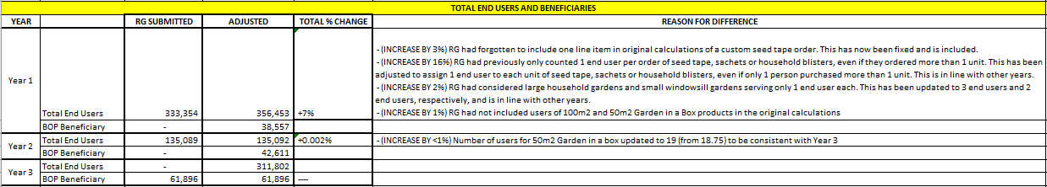
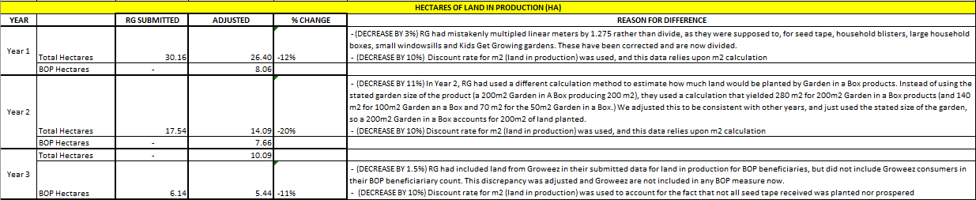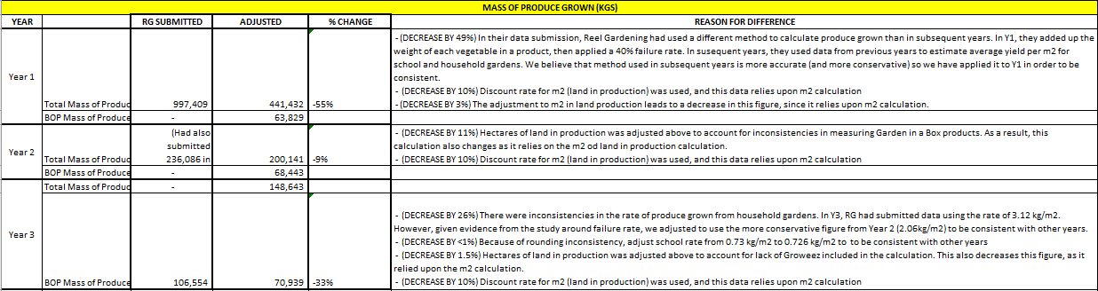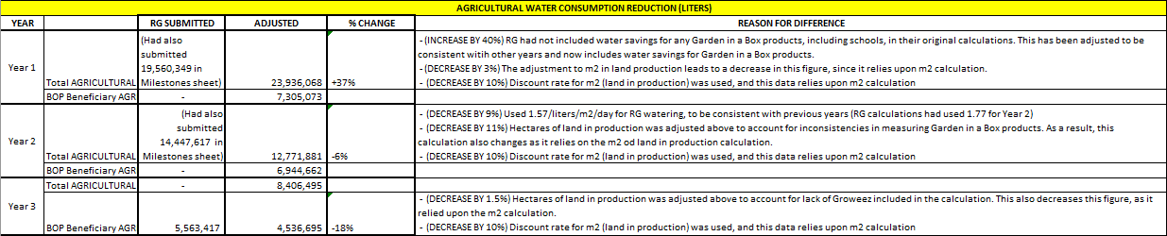

Annex VI: Disclosure of any Conflicts of Interest
Name | Ashley Hartz
Title | Senior Research Manager
Organization | Ipsos
Evaluation Position? | Team Leader Team member
Evaluation Award Number (contract or other instrument) | USAID Contract No. AID-OAA-C-15-00011
USAID Project(s) Evaluated (Include project name(s), implementer name(s) and award number(s), if applicable) | SWFF - Reel Gardening
I have real or potential conflicts of interest to disclose. | Yes No
If yes answered above, I disclose the following facts:
Real or potential conflicts of interest may include, but are not limited to:
- Close family member who is an employee of the USAID operating unit managing the project(s) being evaluated or the implementing organization(s) whose project(s) are being evaluated.
- Financial interest that is direct, or is significant though indirect, in the implementing organization(s) whose projects are being evaluated or in the outcome of the evaluation.
- Current or previous direct or significant though indirect experience with the project(s) being evaluated, including involvement in the project design or previous iterations of the project.
- Current or previous work experience or seeking employment with the USAID operating unit managing the evaluation or the implementing organization(s) whose project(s) are being evaluated.
- Current or previous work experience with an organization that may be seen as an industry competitor with the implementing organization(s) whose project(s) are being evaluated.
- Preconceived ideas toward individuals, groups, organizations, or objectives of the particular projects and organizations being evaluated that could bias the evaluation.
I certify (1) that I have completed this disclosure form fully and to the best of my ability and (2) that I will update this disclosure form promptly if relevant circumstances change. If I gain access to proprietary information of other companies, then I agree to protect their information from unauthorized use or disclosure for as long as it remains proprietary and refrain from using the information for any purpose other than that for which it was furnished.
Signature | Ashley Hartz
Date | April 18, 2018

Name | Marika Klein
Title | Senior Research Analyst
Organization | Ipsos
Evaluation Position? | Team Leader Team member
Evaluation Award Number (contract or other instrument) | USAID Contract No. AID-OAA-C-15-00011
USAID Project(s) Evaluated (Include project name(s), implementer name(s) and award number(s), if applicable) | SWFF - Reel Gardening
I have real or potential conflicts of interest to disclose. | Yes No
If yes answered above, I disclose the following facts:
Real or potential conflicts of interest may include, but are not limited to:
- Close family member who is an employee of the USAID operating unit managing the project(s) being evaluated or the implementing organization(s) whose project(s) are being evaluated.
- Financial interest that is direct, or is significant though indirect, in the implementing organization(s) whose projects are being evaluated or in the outcome of the evaluation.
- Current or previous direct or significant though indirect experience with the project(s) being evaluated, including involvement in the project design or previous iterations of the project.
- Current or previous work experience or seeking employment with the USAID operating unit managing the evaluation or the implementing organization(s) whose project(s) are being evaluated.
- Current or previous work experience with an organization that may be seen as an industry competitor with the implementing organization(s) whose project(s) are being evaluated.
- Preconceived ideas toward individuals, groups, organizations, or objectives of the particular projects and organizations being evaluated that could bias the evaluation.
I certify (1) that I have completed this disclosure form fully and to the best of my ability and (2) that I will update this disclosure form promptly if relevant circumstances change. If I gain access to proprietary information of other companies, then I agree to protect their information from unauthorized use or disclosure for as long as it remains proprietary and refrain from using the information for any purpose other than that for which it was furnished.
Signature | Marika Klein
Date | April 18, 2018

Name | Kaitlin Love
Title | Director
Organization | Ipsos
Evaluation Position? | Team Leader Team member
Evaluation Award Number (contract or other instrument) | USAID Contract No. AID-OAA-C-15-00011
USAID Project(s) Evaluated (Include project name(s), implementer name(s) and award number(s), if applicable) | SWFF - Reel Gardening
I have real or potential conflicts of interest to disclose. | Yes No
If yes answered above, I disclose the following facts:
Real or potential conflicts of interest may include, but are not limited to:
- Close family member who is an employee of the USAID operating unit managing the project(s) being evaluated or the implementing organization(s) whose project(s) are being evaluated.
- Financial interest that is direct, or is significant though indirect, in the implementing organization(s) whose projects are being evaluated or in the outcome of the evaluation.
- Current or previous direct or significant though indirect experience with the project(s) being evaluated, including involvement in the project design or previous iterations of the project.
- Current or previous work experience or seeking employment with the USAID operating unit managing the evaluation or the implementing organization(s) whose project(s) are being evaluated.
- Current or previous work experience with an organization that may be seen as an industry competitor with the implementing organization(s) whose project(s) are being evaluated.
- Preconceived ideas toward individuals, groups, organizations, or objectives of the particular projects and organizations being evaluated that could bias the evaluation.
I certify (1) that I have completed this disclosure form fully and to the best of my ability and (2) that I will update this disclosure form promptly if relevant circumstances change. If I gain access to proprietary information of other companies, then I agree to protect their information from unauthorized use or disclosure for as long as it remains proprietary and refrain from using the information for any purpose other than that for which it was furnished.
Signature | Kaitlin Love
Date | April 18, 2018

Name | Meghann Jones
Title | Senior Vice President
Organization | Ipsos
Evaluation Position? | Team Leader Team member
Evaluation Award Number (contract or other instrument) | USAID Contract No. AID-OAA-C-15-00011
USAID Project(s) Evaluated (Include project name(s), implementer name(s) and award number(s), if applicable) | SWFF - Reel Gardening
I have real or potential conflicts of interest to disclose. | Yes No
If yes answered above, I disclose the following facts:
Real or potential conflicts of interest may include, but are not limited to:
- Close family member who is an employee of the USAID operating unit managing the project(s) being evaluated or the implementing organization(s) whose project(s) are being evaluated.
- Financial interest that is direct, or is significant though indirect, in the implementing organization(s) whose projects are being evaluated or in the outcome of the evaluation.
- Current or previous direct or significant though indirect experience with the project(s) being evaluated, including involvement in the project design or previous iterations of the project.
- Current or previous work experience or seeking employment with the USAID operating unit managing the evaluation or the implementing organization(s) whose project(s) are being evaluated.
- Current or previous work experience with an organization that may be seen as an industry competitor with the implementing organization(s) whose project(s) are being evaluated.
- Preconceived ideas toward individuals, groups, organizations, or objectives of the particular projects and organizations being evaluated that could bias the evaluation.
I certify (1) that I have completed this disclosure form fully and to the best of my ability and (2) that I will update this disclosure form promptly if relevant circumstances change. If I gain access to proprietary information of other companies, then I agree to protect their information from unauthorized use or disclosure for as long as it remains proprietary and refrain from using the information for any purpose other than that for which it was furnished.
Signature | Meghann Jones
Date | April 18, 2018

Securing Water for Food: A Grand Challenge for Development
www.securingwaterforfood.org

1300 Pennsylvania Avenue, NW
Washington, DC 20523

A comprehensive list of these documents can be found in Annex IV: Sources of Information.
See Annex IV: Sources of Information
SWFF granted Reel Gardening a 6-month no cost extension
See Figure 1: Hypothesis of Change
Trainer reports from Y1/Y2 did not consider how many students benefitted.
See Theory of Change in Project Background.
Y1/Y2 school garden sites range in size from 15 learners to 2,500, with a mean of 801 students and a median of 691 students. Thus, 150 students per school is an average of 19%.
This is an estimate of gender based on analysis of names associated with each product sale. In Y1, no first names were included, so data could be not analyzed. For Y2 and Y3, only names where gender could confidently be determined were included in this analysis.
Some schools were selected for an earlier study by a student evaluator. The schools prepared for the evaluation, but it never occurred, incurring some bad feelings. Reel Gardening would like to preserve their relationships with these schools by not asking them to participate again. Ipsos will maintain a close watch on the rate that schools are rejected by Reel Gardening and alert SWFF for action as necessary.

